St Paul’s Primary School
Calculation Policy

The following calculation policy has been devised to meet requirements of the National Curriculum 2014 for the teaching and learning of mathematics, and is also designed to give pupils a consistent and smooth progression of learning in calculations across the school. Please note that early learning in number and calculation in Reception follows the Development Matters EYFS document, and this calculation policy is designed to build on progressively from the content and methods established in the Early Years Foundation Stage.

Age stage expectations
The calculation policy is organised according to age stage expectations as set out in the National Curriculum 2014, however it is vital that pupils are taught according to the stage that they are currently working at, being moved onto the next level as soon as they are ready, or working at a lower stage until they are secure enough to move on.

Providing a context for calculation:
It is important that any type of calculation is given a real life context or problem solving approach to help build children’s understanding of the purpose of calculation, and to help them recognise when to use certain operations and methods when faced with problems. This must be a priority within calculation lessons.

Choosing a calculation method:
To work out a tricky calculation:
Approximate,
Calculate,
Check it!
Children need to be taught and encouraged to use the following processes in deciding what approach they will take to a calculation, to ensure they select the most appropriate method for the numbers involved:

Can I do it in my head using a
mental strategy?

Could I use some jottings to
help me?

Should I use a written method to
work it out?

New Mathematics Calculation Policy: Year 1
Addition | Subtraction
The + and = signs and missing numbers  Children need to understand the concept of equality before using the ‘=’ sign. Calculations should be written either side of the equality sign so that the sign is not just interpreted as ‘the answer’.  Example  2 = 1+ 1  - + 3 = 4 + 1  - = 3  - + 2 + 2 = 4 + 2  Missing numbers need to be placed in all possible places.  - + 4 = = 3 + 4  3 + = 7 7 = + 4  + 4 = 7 7 = 3 +  Use of prepared number  lines and concrete objects  2  3  4  5  6  7  8  9  10  11  12  Children are encouraged to record by drawing jumps on prepared lines. | The - and = signs and missing numbers The notes opposite are relevant here.  7 - 3 = = 7 - 3  7 - = 4 4 = - 3  Use of pictures, marks and concrete objects  Sam spent 4p. What was his change from 10p?  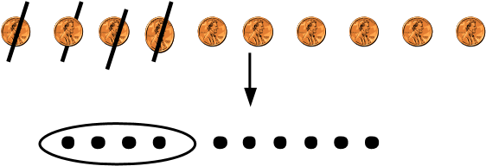  Number Lines  Example- Counting Back/Down  11 – 7  0 1 2 3 4 5 6 7 8 9 10 11 12  Example- Counting On/Up  The difference between 7 and 11  0 1 2 3 4 5 6 7 8 9 10 11 12  Children are encouraged to record by drawing jumps on prepared lines and constructing their own lines.
Multiplication | Division
Use of pictures and objects There are 3 sweets in one bag.  How many sweets are there in 5 bags?  Count in multiples of one, two, five and ten Counting steps using bead string and on prepared number lines.  Counting in multiples using a range of objects, e.g. pairs of legs on animals; fingers in gloves etc.  Counting in rows and columns  Two groups of three is six  Three groups of two is six  So 6 = 2 + 2 +2 or 6 = 3 + 3 | Use of pictures and objects or marks 12 children get into teams of 4 to play a game. How many teams are there?  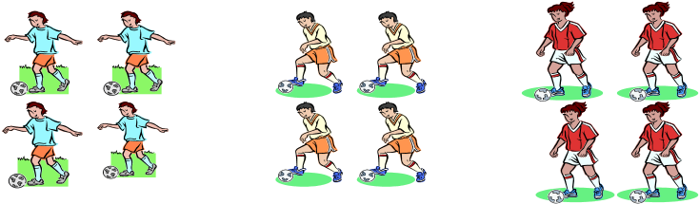  6 sweets are shared between 2 people. How many do they have each?            Make use of practical activities involving sharing, e.g. distributing cards when playing a game, putting objects onto plates, into cups, hoops etc.

New Curriculum Mathematics Calculation Policy: Year 2
Addition | Subtraction
The + and = signs and missing numbers Continue using a range of equations (See Year 1) but with appropriate, larger numbers as specified in Year 2 gradelevel standards, i.e. extend to 14 + 5 = 10 + and 32 + + = 100 35 = 1 + + 5.  Partition into tens and ones and recombine  12 + 23 = 10 + 2 + 20 + 3  = 30 + 5  = 35  Partitioning the second number only  23 + 12 = 23 + 10 + 2  +10  +2  = 33 + 2  = 35 23 33 35  Example: Add 9 or 11 by adding 10 and adjusting by 1 35 + 9 = 44 | The – and = signs and missing numbers Continue using a range of equations (See Year 1) but with appropriate numbers in relation to Year 2 grade-level standards, i.e. extend to 14 + 5 = 20 - .  Find a small difference by counting up  42 – 39 = 3 + 1 + 2  39 40 42  Example: Subtract 9 or 11 & begin to add/subtract 19 or 21  35 – 9 = 26 ₊₁  -10  25  3  5  26  Use known number facts and place value to  subtract (Partition second number only) 37 – 12 = 37 – 10 – 2 ₂₅ ²⁷ ₃₇ = 27 – 2  = 25 ⁻² ⁻¹⁰
Multiplication | Division
The x and = signs and missing numbers  7 x 2 = = 2 x 7  7 x = 14 14 = x 7 x 2 = 14 14 = 2 x  Use materials, arrays, repeated addition  (including solving problems in context)      4 x 2 or 4 + 4      2 x 4  Or repeated addition  0 1 2 3 4 5 6 7 8  2 + 2 + 2 + 2  Partitioning  x 10 5  2 20 10  15 x 2 OR  20 + 10 = 30 | The ÷ and = signs and missing numbers  6 ÷ 2 = = 6 ÷ 2  6 ÷ = 3 3 = 6 ÷  ÷ 2 = 3 3 = ÷ 2  Use materials, arrays, repeated addition  (including solving problems in context)  Use of sharing and grouping  Sharing  6 sweets are shared between 2 people.  How many do they have each?            Grouping  There are 6 sweets.  How many people can have 2 each? (How many 2’s make  6?)  0 2 4 6  Find and name fractions of length, shape and sets of objects and quantities  Use of diagrams- count all equal parts to determine denominator. Link to division into equal groups/parts.

New Curriculum Mathematics Calculation Policy: Year 3*
Addition | Subtraction
The + and = signs and missing numbers  Continue using a range of equations as in Year 1 and Year 2 but with appropriate larger numbers specified in the gradelevel standards.  Progression in mental calculations with larger numbers  Calculate HTU + U  Calculate HTU + TU  Calculate HTU + HTU  Progress from no crossing of boundaries to crossing of boundary.  Partition into tens and ones and recombine Develop from Year 2- partitioning both numbers and recombining.  Refine to partitioning the second number only:  36 + 53 = 53 + 30 + 6  +30  +6  = 83 + 6  = 89 ₅₃ ₈₃ ₈₉  Add a near multiple of 10 to a two-digit number Continue work from Year 2 but with appropriate numbers: 35 + 19 is the same as 35 + 20 – 1.  Formal methods of columnar addition to add numbers with up to three digits  285  +73  8  150  200  358  Extend to decimals in the context of money  £ 2.50 + £ 1.75  £ 2.50  + £ 1.75  £ 4.25  1  The expanded method should be used if children experience persisting difficulties.  *From Year 3 onwards, teachers need to keep in mind the methods specified in grade-level standards for end of Key Stage 2 (See Year 5 and Year 6 Calculation Policy Document). Children should be developing their capacity to use formal written methods for all four number operations. | The - and = signs and missing numbers  Continue using a range of equations as in Year 1 and Year 2 but with appropriate larger numbers specified in the gradelevel standards.  Find a small difference by counting up  Continue from Year 2 but with appropriate numbers, e.g. 102 – 97 = 5  Subtract mentally a ‘near multiple of 10’ to or from a two-digit number, extending to threedigit numbers  Continue as in Year 2 but with appropriate numbers e.g. 78 – 49 is the same as 78 – 50 + 1  Progression in mental calculations with larger numbers Calculate HTU - U  Calculate HTU - T  Calculate HTU - H  Progress from no crossing of boundaries to crossing of boundary.  + 20  Complementary addition + 4 ⁺ ⁴  84 – 56 = 28  56 60 80 84  Formal methods of columnar subtraction to subtract numbers with up to three digits  See Appendix 1 examples in Year 5 and Year 6 section of this document.  *From Year 3 onwards, teachers need to keep in mind the methods specified in grade-level standards for end of Key Stage 2 (See Year 5 and Year 6 Calculation Policy Document). Children should be developing their capacity to use formal written methods for all four number operations.

Multiplication | Division
The x and = signs and missing numbers Continue using a range of equations as in Year 2 but with appropriate numbers in relation to grade-level standards.  TU x U  Use known facts x3, x4, x8 (Year 3 grade-level standards) and x2, x5 and x10 (Year 2 grade-level standards).  x 30 5 2 60 10 x 30 2 3 90 6  At Year 3, children progress to using more formal written methods. In this case, the grid method drawing on knowledge of place value, multiplication facts and their ability to recombine partitioned numbers to derive an answer.  *From Year 3 onwards, teachers need to keep in mind the methods specified in grade-level standards for end of Key Stage 2 (See Year 5 and Year 6 Calculation Policy Document). Children should be developing their capacity to use formal written methods for all four number operations. | The ÷ and = signs and missing numbers Continue using a range of equations as in Year 2 but with appropriate numbers in relation to grade-level standards.  TU ÷ U Grouping  How many 3s make 18? 0 3 6 9 12 15 18  Remainders  16 ÷ 3 = 5 r1  Sharing – There are 16 sweets shared between 3, how many left over?  Grouping – How many 3s make 16, how many left over?  0 3 6 9 12 15 16  Children with secure knowledge of multiplication facts and subtraction may progress to ‘chunking’ where TU are divided by U.  *From Year 3 onwards, teachers need to keep in mind the methods specified in grade-level standards for end of Key Stage 2 (See Year 5 and Year 6 Calculation Policy Document). Children should be developing their capacity to use formal written methods for all four number operations.

New Mathematics Calculation Policy: Year 4
Addition | Subtraction
The + and = signs and missing numbers  Continue using a range of equations as in Key Stage 1 and Year 3 but with appropriate numbers.  Partition into hundreds, tens and ones and recombine Either partition both numbers and recombine or partition the second number only e.g.  358 + 73 = 358 + 70 + 3  = 428 + 3  = 431  Add or subtract the nearest multiple of 10 or 100, then adjust  Continue as in Year 2, 3 and 4 but with appropriate numbers e.g. 458 + 79 = is the same as 458 + 80 - 1  Addition of numbers with at least four digits using formal method of columnar addition  358  +73 431  1 1  3587  +675 4262  1 1 1  The formal, efficient method of columnar addition will involve crossing of boundaries (at the tens, hundreds and/or thousands). Take a systematic approach to teaching this looking at crossing each boundary in turn before mixed practice.  Revert to expanded method if children experience difficulties.  Extend addition to decimals (same number of decimals places) and adding several numbers (with different numbers of digits).  As specified in Year 3, teachers need to keep in mind the methods specified in grade-level standards for end of Key Stage 2 (See Year 5 and Year 6 Calculation Policy Document). Children should be developing their capacity to use formal written methods for all four number operations. | The – and = signs and missing numbers  Continue using a range of equations as in Key Stage 1 and Year 3 but with appropriate numbers.  Differences  Find a difference by counting up, e.g. 8006 – 2993 = 5013. This can be modelled on an empty number line.  Use known number facts and place value to subtract  6.1 – 0.4 = 5.7  5.7 6.0 6.1  -0. 3 -0 .1  Subtraction with at least four digits using formal method of columnar subtraction  For instance, 6467 – 2684 = 3783 Using expanded column subtraction where children experience difficulty with decomposition and need to ‘see’ this.  Extend subtraction to decimals (same number of decimals places) and adding several numbers (with different numbers of digits)  As specified in Year 3, teachers need to keep in mind the methods specified in grade-level standards for end of Key Stage 2 (See Year 5 and Year 6 Calculation Policy Document). Children should be developing their capacity to use formal written methods for all four number operations.

Multiplication | Division
The x and = signs and missing numbers  Continue using a range of equations but with appropriate numbers for Year 4.  TU x U (See Year 3) and HTU x U (Introduced in Year 4 grade-level standards).  Partition  23 x 4 = 92  23 x 4 = (20 x 4) + (3 x 4)  = (80) + (12)  = 92  Use the grid method of multiplication  23 x 7 is approximately 20 x 10 = 200  x 20 3  7 140 21  As specified in Year 3, teachers need to keep in mind the methods specified in grade-level standards for end of Key Stage 2 (See Year 5 and Year 6 Calculation Policy Document). Children should be developing their capacity to use formal written methods for all four number operations. | The ÷ and = signs and missing numbers  Continue using a range of equations but with appropriate numbers for Year 4.  Sharing and grouping 30 ÷ 6 can be modelled as:  Grouping – groups of 6 taken away and the number of groups counted e.g.  6 + 6 + 6 + 6 + 6  +  0 6 12 18 24 30  Sharing – sharing among 6, the number given to each person.  Remainders  Note three approaches below:  41 ÷ 4 = 10 r1 ₊₄₀  +1  10  groups  10  x  4  41 = (10 x 4) + 1  ₋1  - 40  TU ÷ U  72 ÷ 5 lies between 50 ÷ 5 = 10 and 100 ÷ 5 = 20  72  - 50 (10 groups) or (10 x 5)  22  - 20 (4 groups) or (4 x 5)  2 Answer: 14 remainder 2  HTU ÷ U  Can progress from no remainder to remainders. Where remainders are involved, care needs to be taken to ensure they are interpreted correctly in context of problems.  256 ÷ 7 lies between 210 ÷ 7 = 30 and 280 ÷ 7 = 40  256  - 70 (10 groups) or (10 x 7) 186  - 140 (20 groups) or (20 x 7) 46  - 42 (6 groups) or (6 x 7)  4 (36 groups) or (36) Answer: 36 remainder 4  As specified in Year 3, teachers need to keep in mind the methods specified in grade-level standards for end of Key Stage 2 (See Year 5 and Year 6 Calculation Policy Document). Children should be developing their capacity to use formal written methods for all four number operations.

New Mathematics Calculation Policy: Year 5 and Year 6
The exemplification of formal methods here should be taken into account by all Key Stage 2 teachers so children are adequately prepared by Year 5 and into Year 6 to use the means of calculating specified in grade-level standards.
Addition & Subtraction
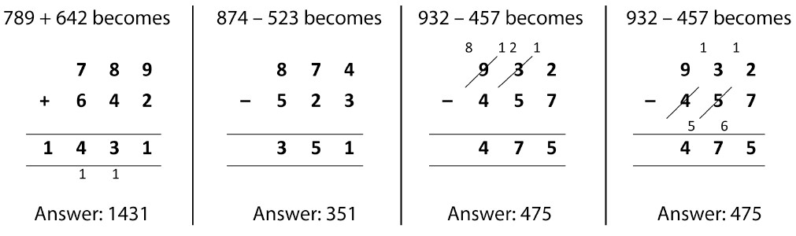
Columnar
Addition &
Subtraction
Multiplication & Division
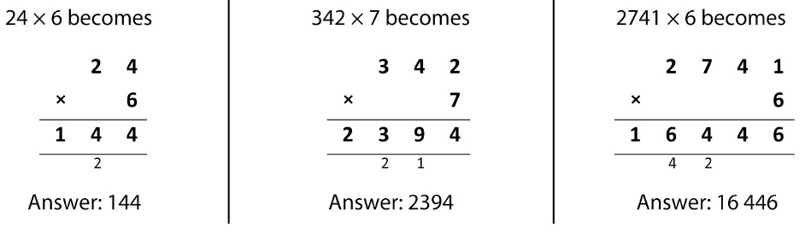
Short Multiplication

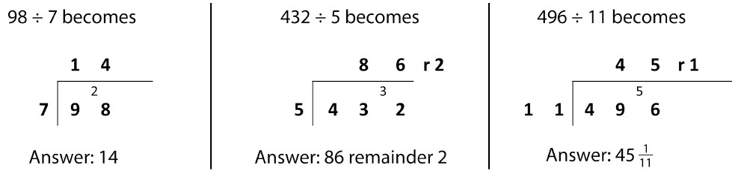
Short Division

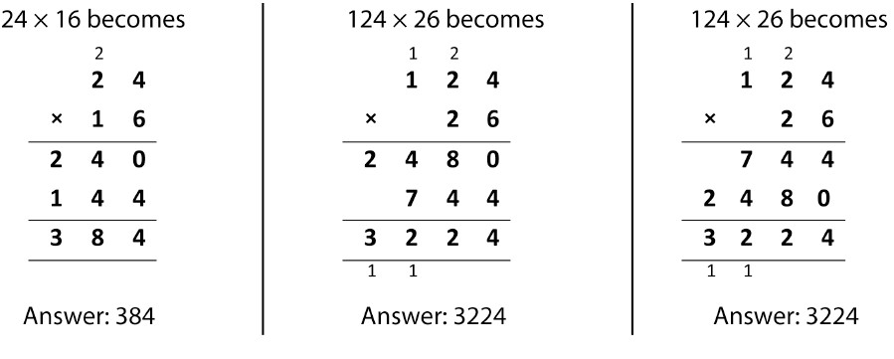
Long
Multiplication

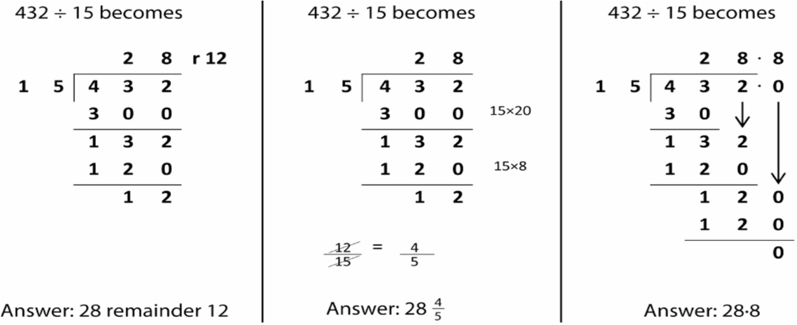
Long Division

