Online Safety Awareness
 | Thinkuknow Parents: Thinkuknow is an education programme from the National Crime Agency’s CEOP Command. It has been keeping children and young people safe by providing education about sexual abuse and sexual exploitation. It is underpinned by the latest intelligence about child sex offending from CEOP Command. www.thinkuknow.co.uk/parents
 | Parents Protect is an information and resources website which aims to raise awareness about child sexual abuse, answer questions and give adults the information, advice, support and facts, they need to help protect children. www.parentsprotect.co.uk/
 | Internet Matters offers information about many of the issues and technologies that children may come across in the online world. From sexting to cyberbullying, our recognised experts help to ensure we provide access to the most up to date and relevant information available for parents. www.internetmatters.org/
 | Parents Info provides high quality information to parents and carers about their children's wellbeing and resilience. This service is free and ranges across a wide range of subject matter, from difficult topics about sex, relationships and the internet or body image and peer pressure to broader parenting topics like ‘how much sleep do teenagers need?’ www.parentinfo.org/
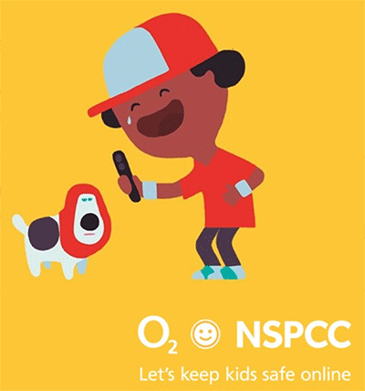 | Share Aware tells children sometimes sharing online can be dangerous. Asking parents to be Share Aware and keep children safe online. Straightforward, no-nonsense advice that will untangle the web, and show how you can be just as great a parent online, as you are the rest of the time. The internet is a great place for children to be. Being Share Aware makes it safer. (Google Share Aware) www.nspcc.org.uk/preventing-abuse/keeping-children-safe/share-aware/
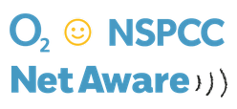 | Net Aware is a guide to the social networks your kids use. Stay up to date and keep your child safe in today's digital world.  www.net-aware.org.uk/
 | UK Safer Internet Centre: The European Commission appointed UK Safer Internet Centre is made up of three partners; Childnet International, the South West Grid for Learning and the Internet Watch Foundation. Together we raise awareness about internet safety, develop information materials and resources and organise high profile events such as Safer Internet Day. You can access a range of resources from across the UK, Europe and wider afield at www.saferinternet.org.uk
 | Childnet International is a non-profit organisation working in partnership with others around the world to help make the internet a great and safe place for children. The Childnet website hosts all the online resources detailed below, as well as a number of recommended resources for young people, parents, carers and teachers. The Parents and Carers area also contains key advice, information on reporting and detailed information on a range of e-safety topics in the Hot topics section. www.childnet.com
 | Get Safe Online is a unique resource providing practical advice on how to protect yourself, your computers and mobiles device and your business against fraud, identity theft, viruses and many other problems encountered online. Every conceivable topic is included on the site – including safe online shopping, gaming and dating … so now you really can stay safe with everything you do online. www.getsafeonline.org
 | ConnectSafely.org is a Silicon Valley, Calif.-based nonprofit organization dedicated to educating users of connected technology about safety, privacy and security. Here you’ll find research-based safety tips, parents’ guidebooks, advice, news and commentary on all aspects of tech use and policy. www.connectsafely.org
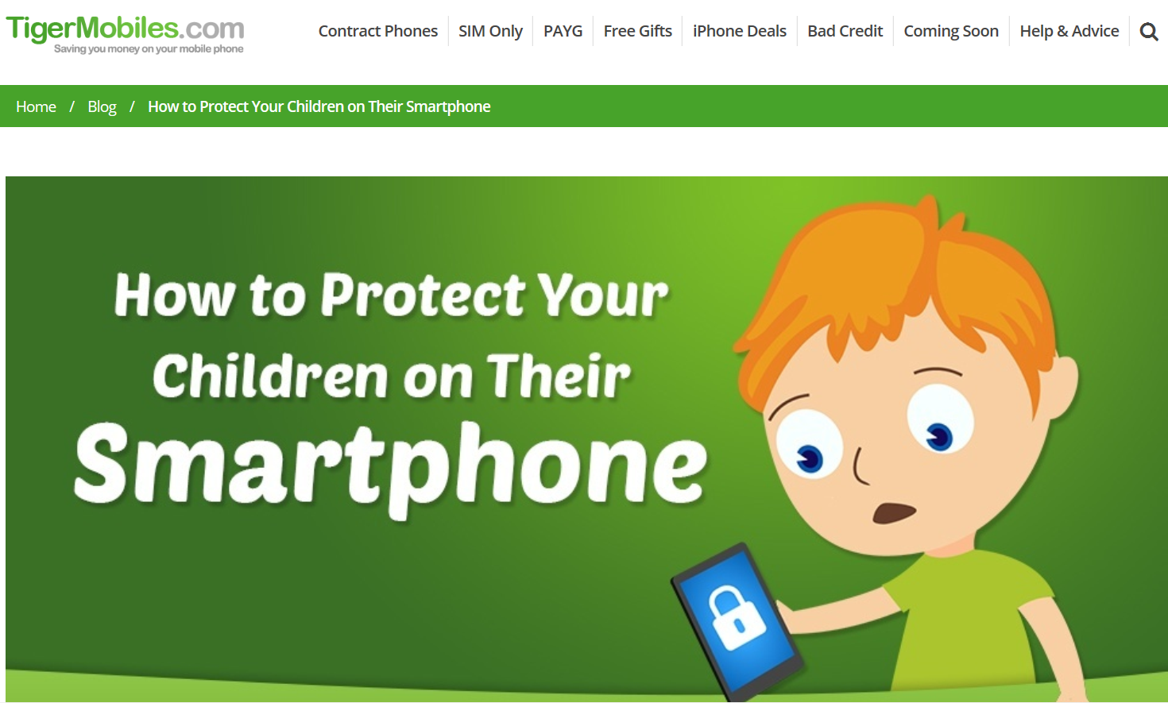 | Tigermobiles.com is a phone website but it has some good advice on how to stay safe using your mobile or tablet. www.tigermobiles.com/2015/05/how-to-protect-your-children-on-their-smartphone/
 | Avast anti-virus Software: One of the best free antivirus software available. You do need to register. So it maybe an idea to create a ‘family email address’ that you can use for internet registrations. www.avast.com/en-gb/index
 | Friendly WiFi: Businesses offering public WiFi and displaying this logo have beenchecked and verified, filters are in place to block pornography and child abuse websites. www.getmedigital.com/friendly-wifi
 | Common Sense Media is dedicated to helping kids thrive in a world of media and technology. We empower parents, teachers, and policymakers by providing unbiased information, trusted advice, and innovative tools to help them harness the power of media and technology as a positive force in all kids’ lives. https://www.commonsensemedia.org/parent-concerns
 | Google Safety Centre and their partners have compiled a short list of helpful resources for getting to know the web. It has sections for parents, teachers and children who are curious about digital literacy and citizenship. www.google.co.uk/safetycenter/
Windows Live Family Safety offers free monitoring and filtering software for Windows Vista/7/8/10 OS
www.account.microsoft.com/family/about
 | South West Grid for Learning (SWGfL) provide professionals, parents and children with advice, resources and support to use internet technologies safely to enhance learning and maximise potential. www.swgfl.org.uk
Celebrated globally every year, Safer Internet Day offers the opportunity to highlight positive uses of technology and to explore the role we all play in helping to create a better safer online community.
www.saferinternetday.org.uk

 | Social Network Checklist: Free guides produced by the UK Safer Internet Centre that contain detailed instructions and information on privacy and account settings on Facebook, Twitter, Snapchat and Instagram. www.saferinternet.org.uk/checklists
 | Child Exploitation and Online Protection (CEOP): A police agency tackling child abuse on the internet. This website includes a unique facility that enables parents and young people to make reports of actual or attempted abuse online. www.thinkuknow.co.uk

 | Internet Watch Foundation: Part of the UK Safer Internet Centre, the IWF is the UK’s hotline for reporting illegal content found on the internet. It deals specifically with child abuse and criminally obscene images hosted in the UK and internationally. www.iwf.org.uk
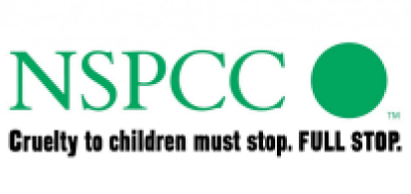 | NSPCC: If you have concerns about the safety of a child then contact the NSPCC helpline on 0808 800 5000 or email help@nspcc.org.uk.  Children can talk to someone for advice and support at any time by contacting ChildLine on 0800 1111 or chatting to a counsellor online at www.childline.org.uk
 | Family Lives: A national family support charity providing help and support in all aspects of family life. Useful advice and information is available online at www.familylives.org.uk and they provide a free confidential helpline on 0808 800 2222.
True Vision: Online content which incites hatred on the grounds of race, religion and sexual orientation can be reported to True Vision; a UK website set up to tackle all forms of hate crime, including those on the grounds of disability and transgender identity.
www.report-it.org.uk

Sites for Children
CBBC - A site designed to teach younger children about some of the pitfalls of the internet in a fun-way; using cartoons, quizzes and games
www.bbc.co.uk/cbbc/help/safesurfing
Cybersmile - Founded by parents of children directly affected by cyberbullying, this non-profit organisation provides support to those that are bullied online, and changes the behaviour of the bullies themselves, through education. www.cybersmile.org
Kidscape - This charity aims to prevent bullying and child sexual abuse, by working with children and young people aged 6 to 19, concerned parents and grandparents, teachers and carers. www.kidscape.org.uk/
Advice for parents of children with special needs
This guide has been produced by Cerebra for children with special needs.
http://www.parentsprotect.co.uk/files/learning_disabilities_autism_internet_safety_parent_guide.pdf
Visit their website at: www.cerebra.org.uk

