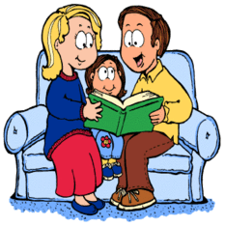
St Paul’s CofE Primary School
Make reading enjoyable and fun
- Make books part of your family life. Always have books around so that you and your children are ready to read whenever there’s a chance.

- Join your local library – Get your child a library card. Allow them to pick their own books, encouraging their own interests.

- Match their interests – Help them find the right book - it doesn’t matter if it’s fiction, poetry, comic books or non-fiction.

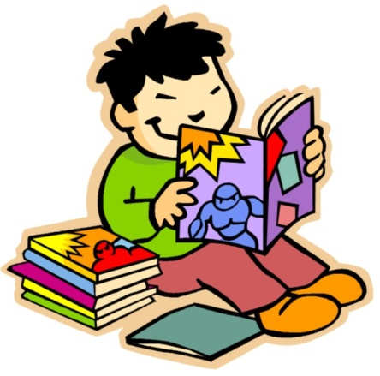
- All reading is good – Don’t discount non-fiction, comics, graphic novels, magazines and leaflets. Reading is reading and it is all good.

- Get comfortable! – Snuggle up somewhere warm and cosy with your child, either in bed, on a beanbag or on the sofa, or make sure they have somewhere comfy when reading alone.

- Ask questions – To keep them interested in the story, ask your child questions as you read such as, ‘What do you think will happen next?’ or ‘Where did we get to last night? Can you remember what has happened already?’

- Read whenever you get the chance – Bring along a book or magazine for any time your child has to wait, such as at a doctor’s surgery.

- Read again and again – Encourage your child to re-read favourite books and poems. Re-reading helps to build up fluency and confidence
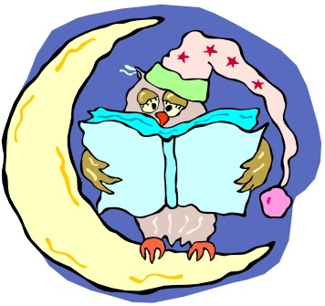

- Bedtime stories – Regularly read with your child or children at bedtime. It’s a great way to end the day and to spend valuable time with your child.

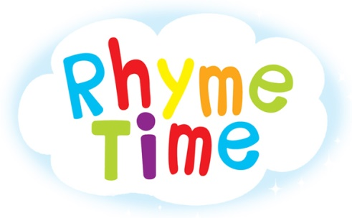

- Rhyme and repetition – Books and poems which include rhyme and repetition are great for encouraging your child or children to join in and remember the words.

Hearing your child read
Key Stage 1
If your child is unsure of a word, help them by asking the following questions:
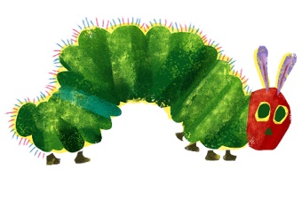
- What do you do if you are stuck on a word?
- What sound do these letters make?
- What word is that when we blend the sounds together?

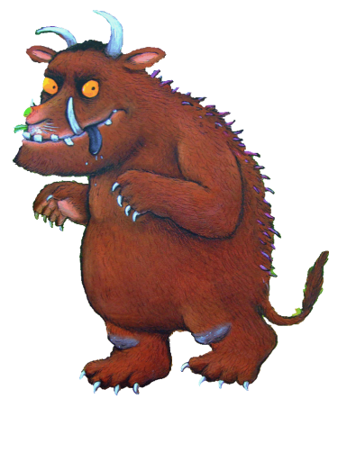
If your child found a word in the sentence tricky please ask them to read the whole sentence again when they have worked out what the word says. We are encouraging the children to read fluently and this will help with that.
You may also like to consider asking your child these questions:
Why do you think that character did that?
What do you think will happen?
Do you know any of the characters in this book?
Did you enjoy this book? Why?
How do you think you could be a better reader?

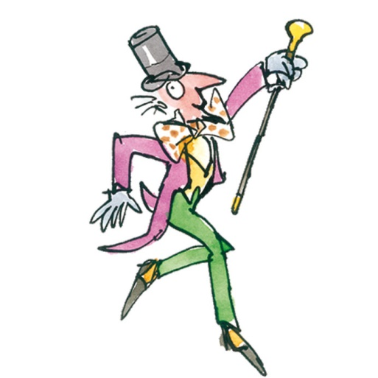
Key Stage2
If your child is unsure of a word, help them to use these strategies:
• Break up the word into its sounds or syllables
• Read the rest of the sentence to see if that helps
• Read the word using only beginning and ending sounds
• Cross check by asking: “Does it sound right? Does it make sense? Does it look right?”

You may also like to consider asking your child these questions:
Could you tell me what’s happened so far in this story?
What is this non-fiction book about?
Do you know what this word means?
Why do you think this character did that?
How do you think he/she is feeling at the moment? Show me the words/phrases that tell you that.
What do you think will happen next? What makes you think that?
How do you think the author wants us to feel at this moment?

