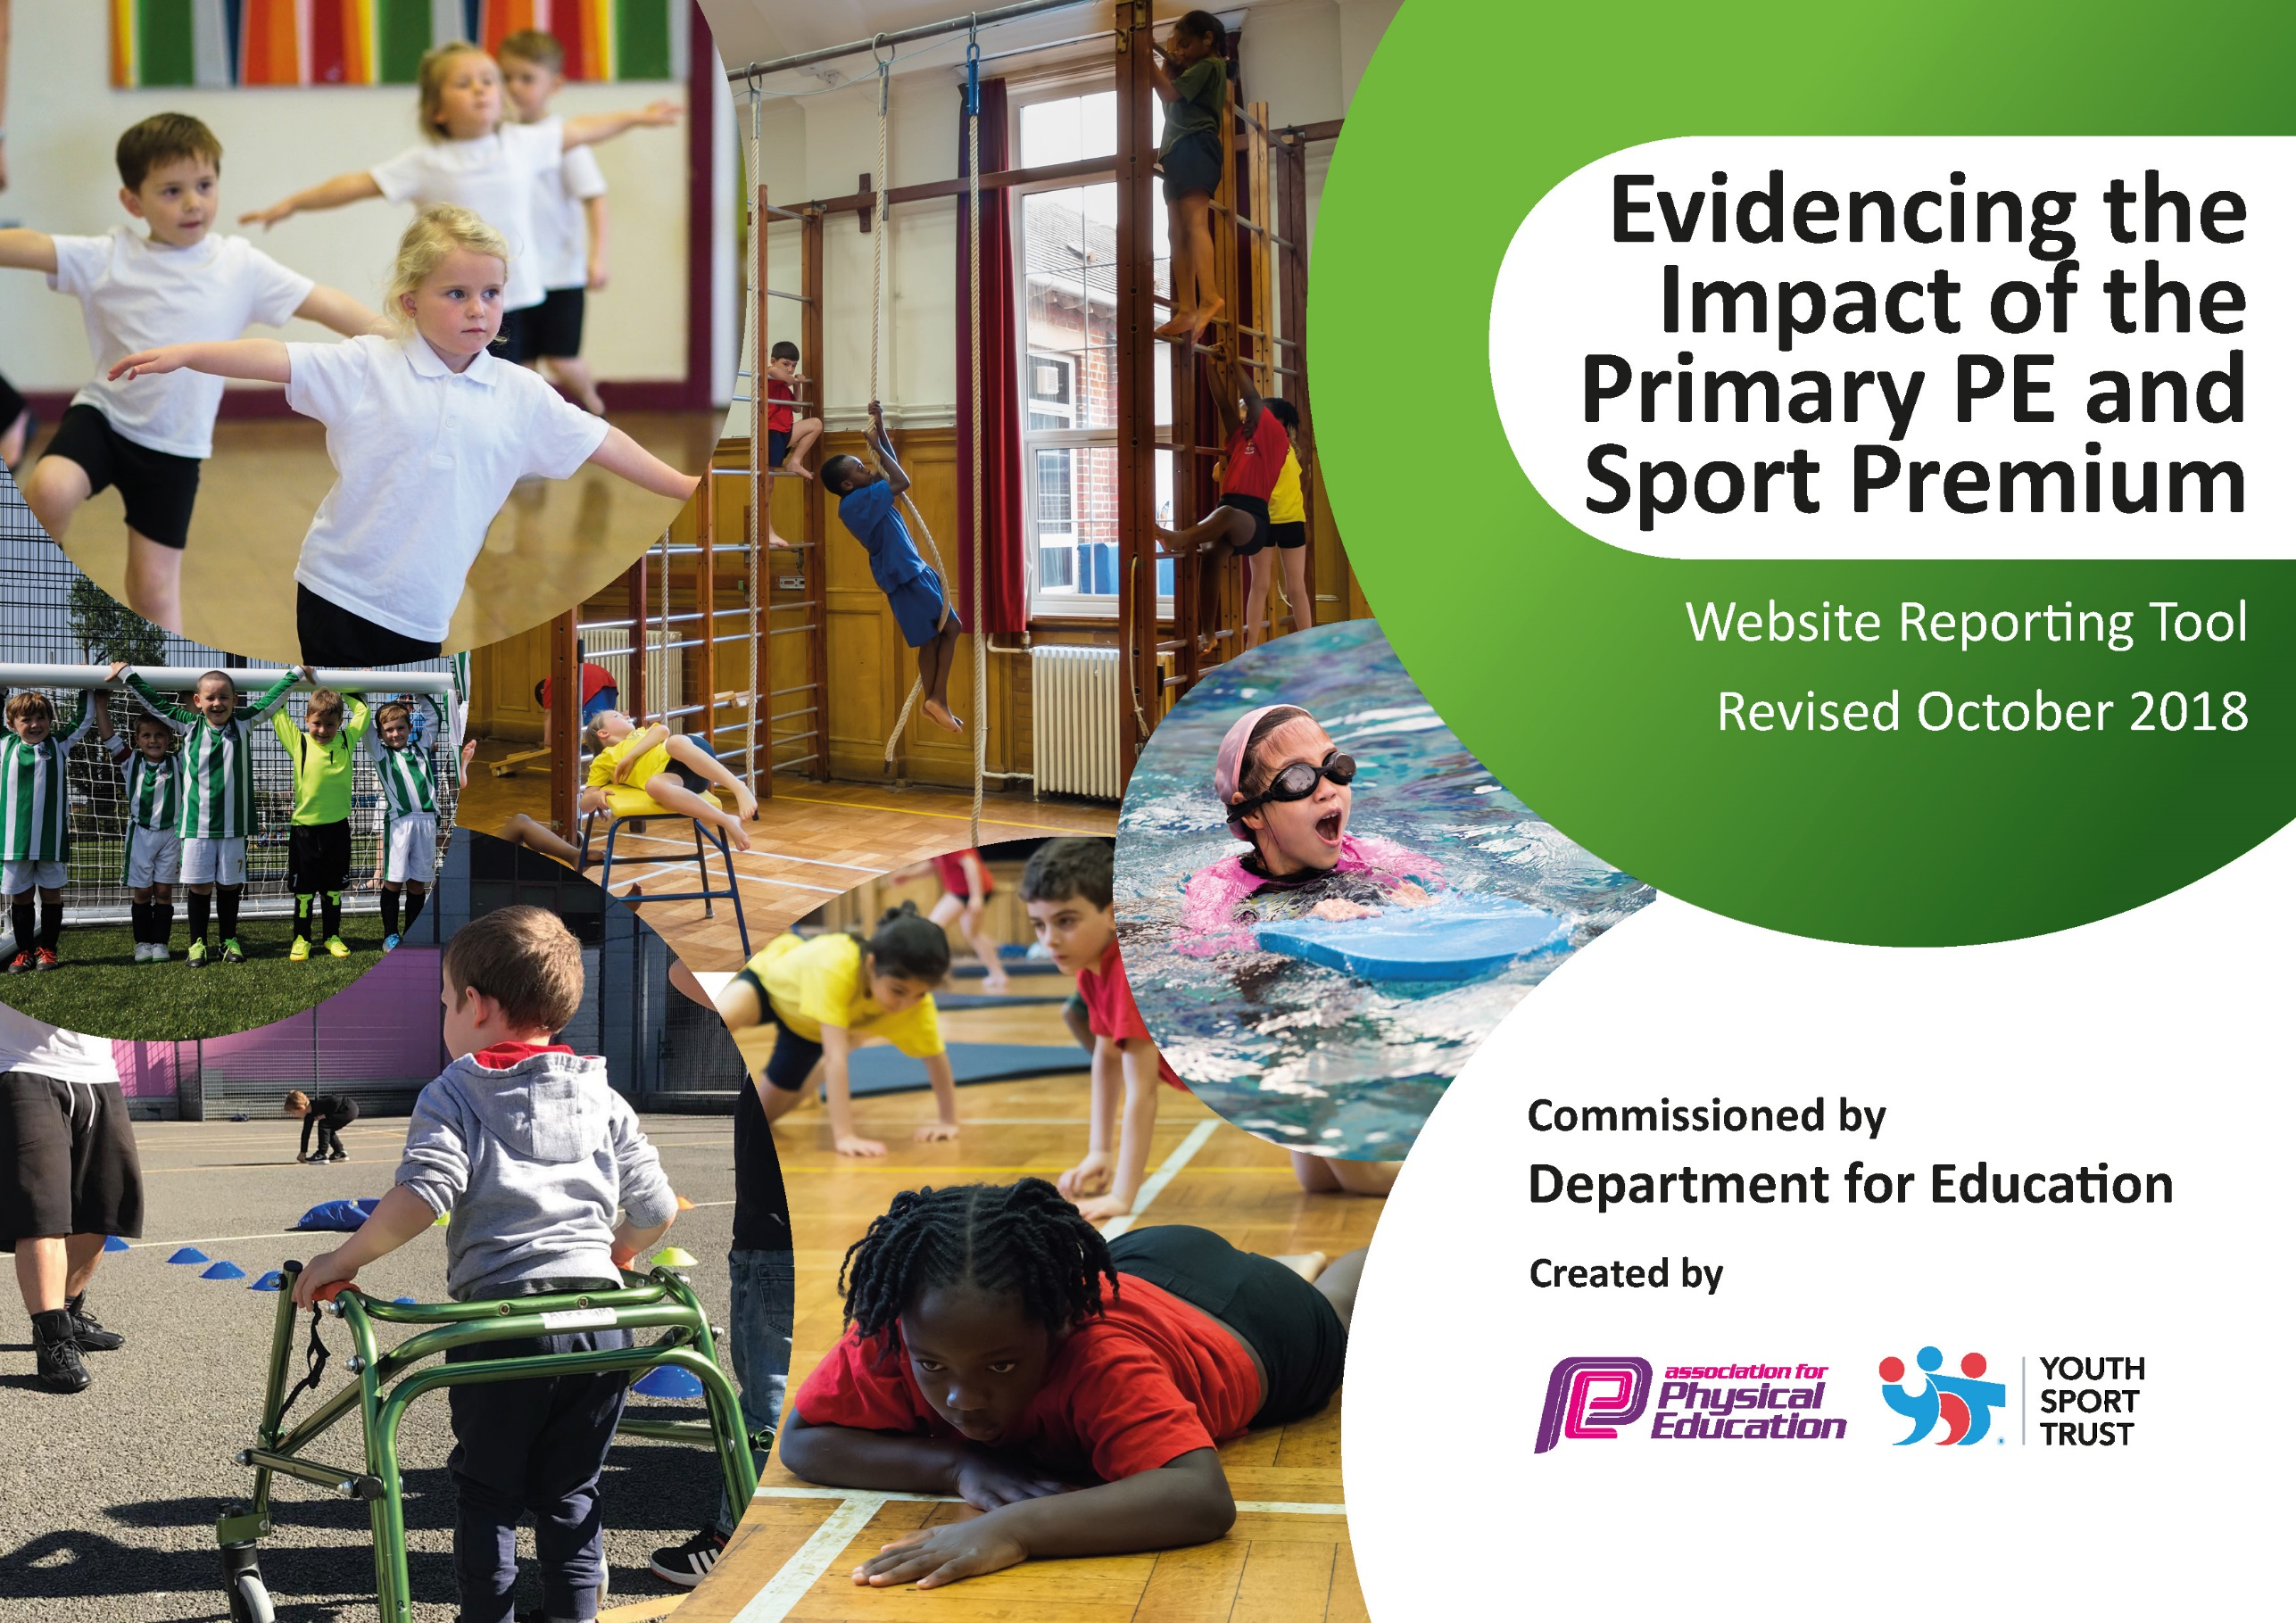
St Paul’s Impact Statement 2018-2019
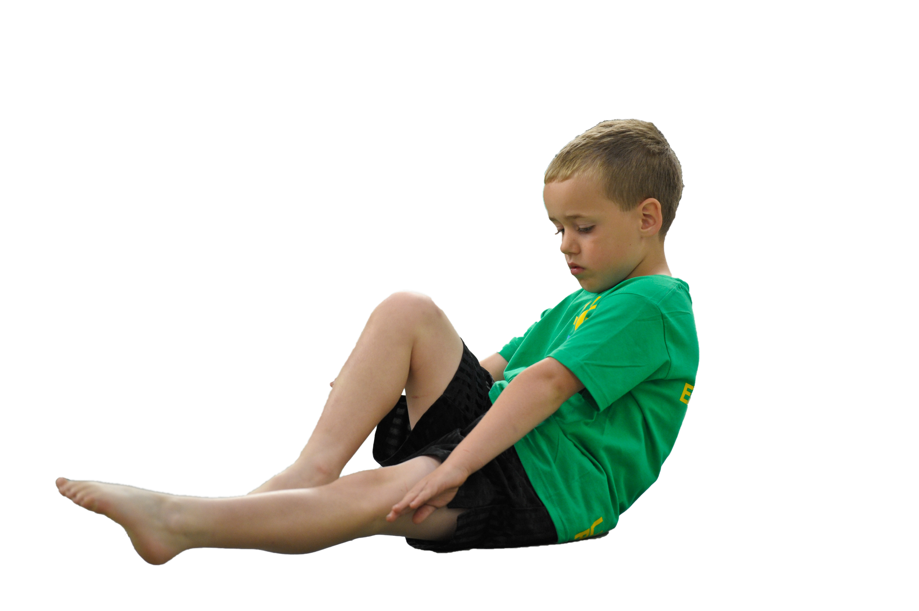
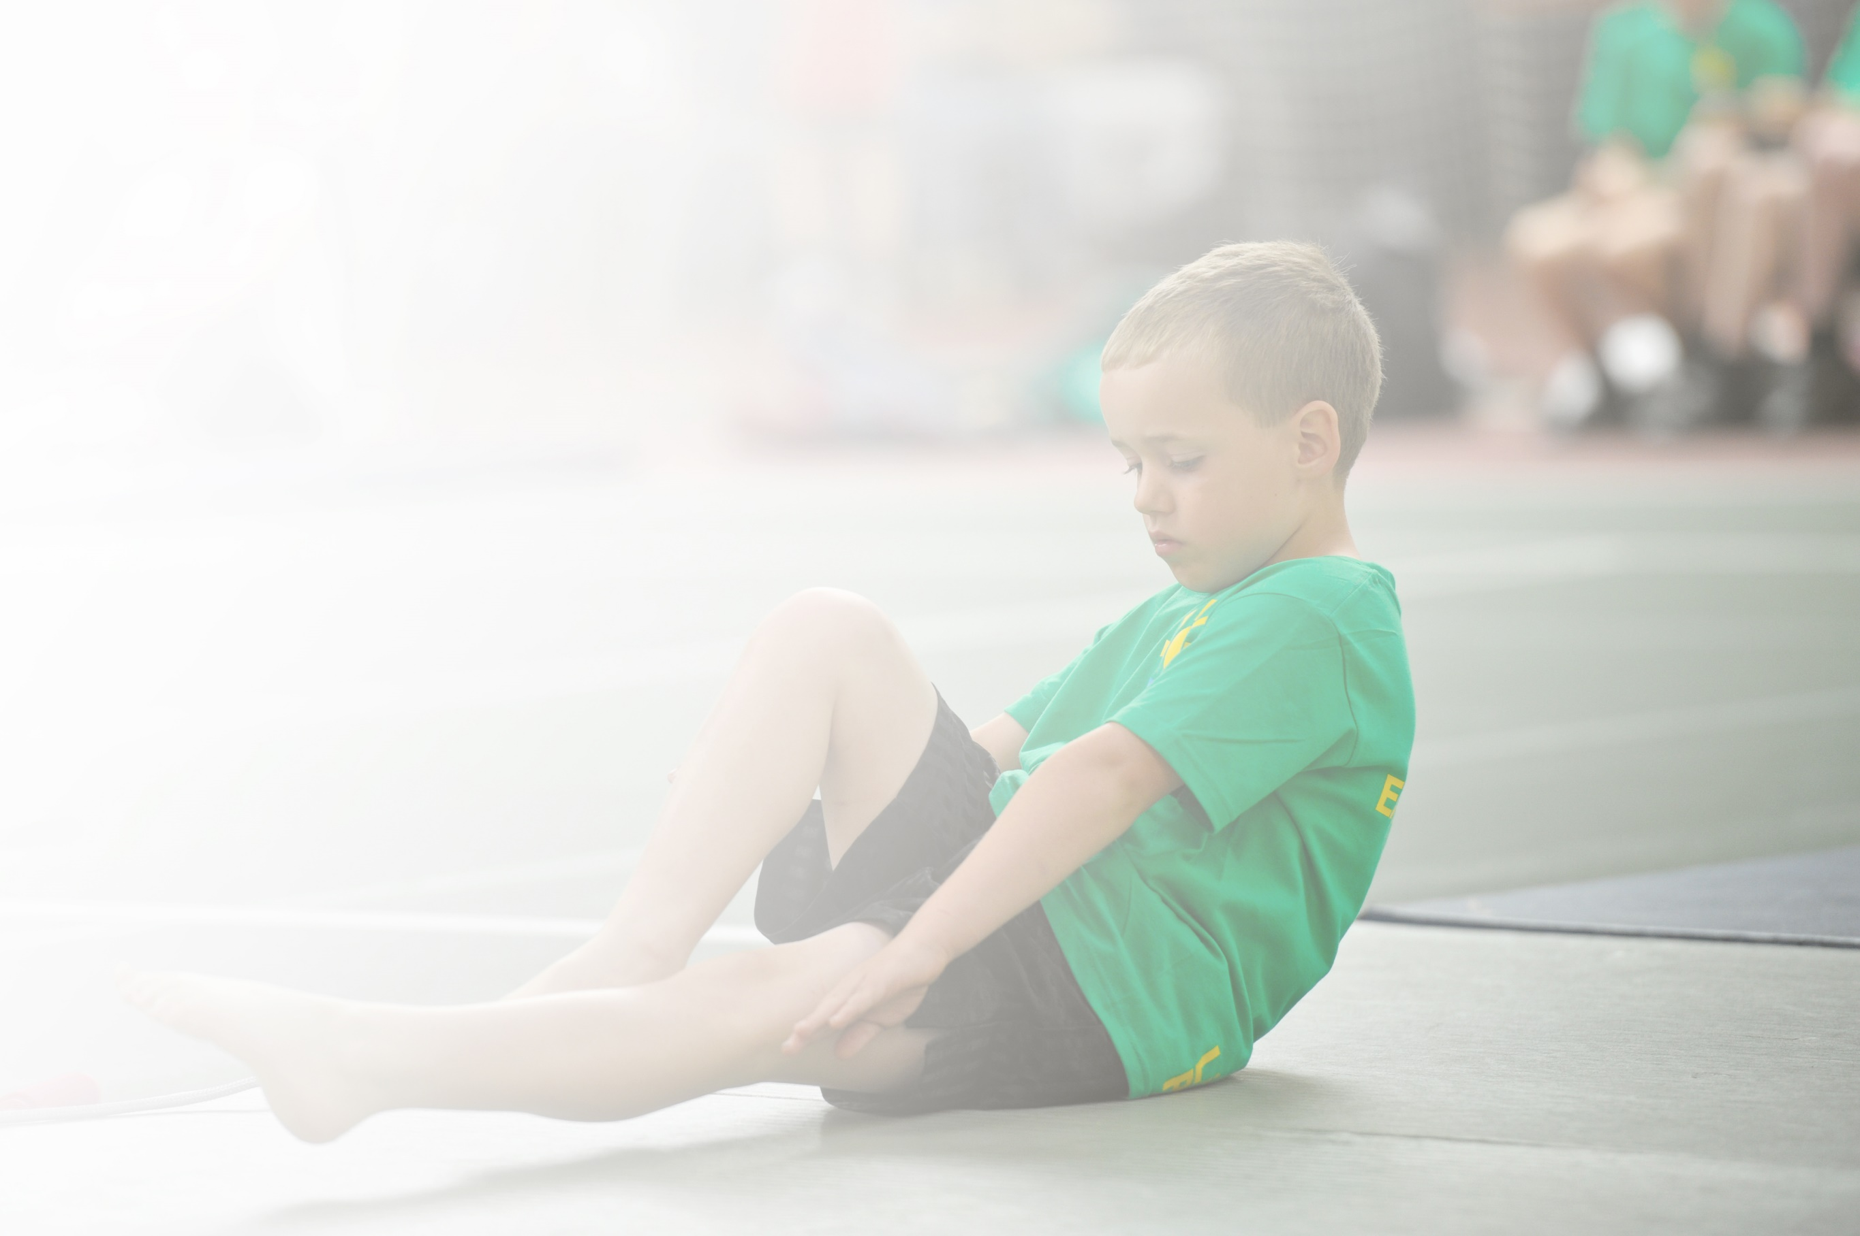
Schools must use the funding to make additional and sustainable improvements to the quality of Physical Education, Sport and Physical Activity (PESPA) they offer. This means that you should use the Primary PE and Sport Premium to:

- Develop or add to the PESPA activities that your school already offer
- Build capacity and capability within the school to ensure that improvements made now will benefit pupils joining the school in future years

Please visit gov.uk for the revised DfE guidance including the 5 key indicators across which schools should demonstrate an improvement. This document will help you to review your provision and to report
your spend. DfE encourages schools to use this template as an effective way of meeting the reporting requirements of the Primary PE and Sport Premium.

We recommend you start by reflecting on the impact of current provision and reviewing the previous
spend. Under the Ofsted Schools Inspection Framework, inspectors will assess how effectively leaders use the Primary PE and Sport Premium and measure its impact on outcomes for pupils, and how effectively governors hold them to account for this.

Schools are required to publish details of how they spend this funding as well as on the impact it has on pupils’ PE and sport participation and attainment by the end of the summer term or by 31 July 2019 at the
latest.
We recommend regularly updating the table and publishing it
on your website throughout the year, as evidence of your
ongoing review into how you are using the money to
secure maximum, sustainable impact. To see an
example of how to complete the table please
click HERE.

Support for review and reflection - considering the 5 key indicators from DfE, what development needs are a priority for your setting and your students now and why? Use the space below to reflect on previous spend, identify current need and priorities for the future.

Key achievements to date: | Areas for further improvement and baseline evidence of need:
1-Staff confidence has been improved through CPD  2-Equipment and resources are vastly improved.  3-Progression in skills has vastly improved thought progression planning.  4-More opportunity for children in keep fit activities.  5-increased Competition engagement intra and inter. | -Engage with active planner as part of the school games program to help encourage 30 active min per child  -Increase engagement in school games competition and apply for school games mark.(Silver)  -Continue to raise the profile of PE and sports within the school  - Further embed daily mile across whole of school  -Further embed playground crew across whole of school

Meeting national curriculum requirements for swimming and water safety | Please complete all of the below:
What percentage of your current Year 6 cohort swim competently, confidently and proficiently over a distance of at least 25 metres?  N.B. Even though your children may swim in another year please report on their attainment on leaving  primary school. | 71.4%
What percentage of your current Year 6 cohort use a range of strokes effectively [for example, front crawl, backstroke and breaststroke]? | 71.4%
What percentage of your current Year 6 cohort perform safe self-rescue in different water-based situations? | 71.4%
Schools can choose to use the Primary PE and Sport Premium to provide additional provision for swimming but this must be for activity over and above the national curriculum requirements. Have you used it in this way? | Yes/No

Action Plan and Budget Tracking
Capture your intended annual spend against the 5 key indicators. Clarify the success criteria and evidence of impact that you intend to measure to evaluate for students today and for the future.

Academic Year: 2018/19 | Total fund allocated: £ | Date Updated:
Key indicator 1: The engagement of all pupils in regular physical activity – Chief Medical Officer guidelines recommend that primary school children undertake at least 30 minutes of physical activity a day in school |  |  |  | Percentage of total allocation:
 |  |  |  | %
School focus with clarity on intended impact on pupils: | Actions to achieve: | Funding allocated: | Evidence and impact: | Sustainability and suggested next steps:
Increase provision of Afterschool clubs provided throughout the year for all year groups in order to engage more children and enable them to achieve their 30 active minutes  Encourage children to engage in more physical activity by implementing active playtimes and lunchtimes, develop leadership opportunities for children to support activities.  Implement more opportunities for children to achieve their 30 active minuets with in the school day | Find a suitably qualified coach that will facilitate this after school provision.  Identify a staff member to be trained to undertake these activities  Identify and train young leaders (hatrick deliver) so as to establish a Playground ‘crew’  Create a time table of activities and zone the yard  Talk to all dinner staff regarding the program and time table.  Provide staff CPD, delivered by Newcastle PE Service  Purchase any equipment needs  Introduce and roll out a Daily Mile initiative, promote with staff, children and parents.  Work with the Tyne and wear Daily Mile officer  Reinforce benefits of Go Noodle with teaching staff and encourage them to use within the classroom.  Reinforce with teaching staff active lessons both inside and outside the classroom. | £720  £ 300 class cover for developing plan  £125  £500 | Pupils attended after school clubs which have include a variety of activities focusing on fitness and healthy active life styles, there has been an increase in take-up of places in these clubs.  15 leaders trained  More children active and more active playground, ‘Crew’ are running daily activities on the large yard.  12th June Daily Mile day across school  March meeting with Tyne and wear daily mile officer.  Summer 2019 Daily Mile implemented within ks1 and ks2.  Discussion in staff meeting about Go Noodle and active lessons.  Notice boards up dated regarding opportunities for active 30 min as well as website, letters home and assemblies. | Aim to increase numbers and extend into KS1 to do this will need to run two clubs.  TA to work with another member of staff to up skill so no need for external coach  Aim to engage higher number of children who are active at play times  Young leaders run activities alone so no need for external coaches  Continue to promote the daily mile within school and talk to teachers about improvements they have seen within their classes. E.g imprudent in concentration and behaviour.  Interview children about their view on the Daily Mile.  Promote all active 30 min opportunities via website, displays, letters home and assemblies.
Key indicator 2: The profile of PESSPA being raised across the school as a tool for whole school improvement |  |  |  | Percentage of total allocation:
 |  |  |  | %
School focus with clarity on intended impact on pupils: | Actions to achieve: | Funding allocated: | Evidence and impact: | Sustainability and suggested next steps:
Celebrate children’s achievements and participation in physical activity and competition  Promote Sports day and encourage parental engagement in order to showcase the children’s skills and raise the profile of PESSPA and competition.  Raise each child’s awareness of the school games core sporting values. | Have assembly when appropriate after competitions  Update and refresh PE notice board to keep children, staff and visitors informed of PE and sports opportunities.  Regular update website with events, photos and news.  Agree on a date and program of events for KS1 and KS2  Book Summer Hill Bowling  Purchase resources needed for this  Ensure all classrooms have the value displayed and that children understand what they are. Have values displayed in the PE hall for children to see. Attended HAL events to reinforce understanding of the values. | £0  £150 | PE celebrations added to school website to raise the profile of PE and sport for children parents and visitors to the website  Increased awareness of what is happening regarding PE and sports at St Paul’s.  Photos, school website, letters to parents, celebration in sports assembly.  Children have taken part in competitive activities in school  All classrooms and PE hall have values displayed; Teachers use the values during PE lessons. Stickers are use during the HAL events. | SLT are aware of PE and sport and the impact it is having across the whole school. They are committed to sustaining the current provision should the funding come to an end.  Run every year SLT have committed to this every year and will support the organization needed.  To continue to engage in the HAL program.  To continue to reinforce with children and staff the values and ensure all new staff are trained and understand the importance of the values.

Key indicator 3: Increased confidence, knowledge and skills of all staff in teaching PE and sport |  |  |  | Percentage of total allocation:
 |  |  |  | %
School focus with clarity on intended  impact on pupils: | Actions to achieve: | Funding  allocated: | Evidence and impact: | Sustainability and suggested  next steps:
Improve staff knowledge, competence and confidence in teaching PE. | Audit staff training needs.  Hire a PE specialist to upskill and support teachers in PE lessons.  Regular planning and development meetings with PE lead and west Trust PE team.  Purchase of Newcastle PE and sports service to support and up skill the PE subject lead.  Ensure curriculum remains progressive by annual review. | £3000  £500 | This academic year we have had Newcastle PE service working alongside teachers to upskill in general fitness as this was highlighted from last year’s audit of staff needs as well as children’s fitness levels.  Photos on website and planning.  Notes from meetings, emails and confidence of PE lead.  School PE curriculum map. | Re audit and find new skills or confidence gaps.  Pay for Newcastle PE service for 2019-2020.  Review PE curriculum map.
Key indicator 4: Broader experience of a range of sports and activities offered to all pupils |  |  |  | Percentage of total allocation:
 |  |  |  | %
School focus with clarity on intended  impact on pupils: | Actions to achieve: | Funding  allocated: | Evidence and impact: | Sustainability and suggested  next steps:
Expose pupils to new sports and formats within the curriculum as well as after school  Provide children with opportunities outside of school to experience a verity of physical activity and sporting opportunities. | Look at current provision, review coverage and address gaps.  Implement new PE block of work.  Attend all H A L events that are run by Newcastle PE and sports service to allow children to participate in health fun active non-traditional sports  Add to school calendar  Book busses  Send letters | £1500  Bus £900  £1000 | Fitness has been added into the curriculum and after school during Autumn 1 / 2 and spring 1. (new block of work)  Hi-5 netball has been introduced as an after school club during spring 2 summer 1 and summer 2.(new block of work)  We have implemented quicksteps gymnastics within the curriculum from year 1 upwards.  Children have developed a sustained fitness level that will benefit them outside of school as well.  Fitness testing data.  Children have enjoyed physical activity that is non-traditional, photos, permission letters and registers.  Children have been signposted and informed about local clubs and opportunities via website and flyers.  Notice board, photos, mentioned in PE celebration assembly school website, register of attendance, school calendar. | Commitment from SLT to support this as they understand the benefit of leading a health active life style.  Book 2019-2020 HAL events and transport.  Keep links with outside clubs and groups and promote opportunities to children and families.  Possibly add hi- 5 into KS2 curriculum for 2019-2020.  TA having now trained in Hi-5 to run afterschool club without support from outside agency.
Key indicator 5: Increased participation in competitive sport |  |  |  | Percentage of total allocation:
 |  |  |  | %
School focus with clarity on intended  impact on pupils: | Actions to achieve: | Funding  allocated: | Evidence and impact: | Sustainability and suggested  next steps:
Engage, expose and prepare children in healthy competitive opportunities. | Establish a quick sticks hockey competition (intra school)  Take part in Trust competition including Football, SEN comps, Girls football  Engage with the school games program so that children are engaging in competitive opportunities though out the school year.  Apply for school games mark – target sliver  Ensure curriculum leads into competition and appropriate NGB resources and formats are used to prepare the children.  Book opportunities for children and add to school diary  Ensure PE calendar links with school games  Highlight G and T children for competition. | £100  £2000 (bus and staff cover) | 21st May quick sticks comp yr 4W and 4M  Children have taken part in trust football, girls football, trust spots day and SEN comp as well as trust virtual athletics.  Children have attended school games competitions, gymnastics, quick sticks and quad kids.  Participation figures  notice board  Children’s comments and pics on school website  Engaging in comp  School games mark grade to be added  Photos, website, certificates and medals, participating figures | Staff have been trained in order to continue running these events in school.  SLT know the importance of competitive engagement and are committed to continuing to support this.  To review curriculum when 2019-2020 competition calendar is released.  Book competitions for 2019-2020 when published.  Talk with staff regarding children who are G and T.  To grow and establish more intra opportunities within the PE curriculum.

