

Schools must use the funding to make additional and sustainable improvements to the quality of PE and sport they offer. This means that you should use the Primary PE and Sport Premium to:

- develop or add to the PE and sport activities that your school already offers
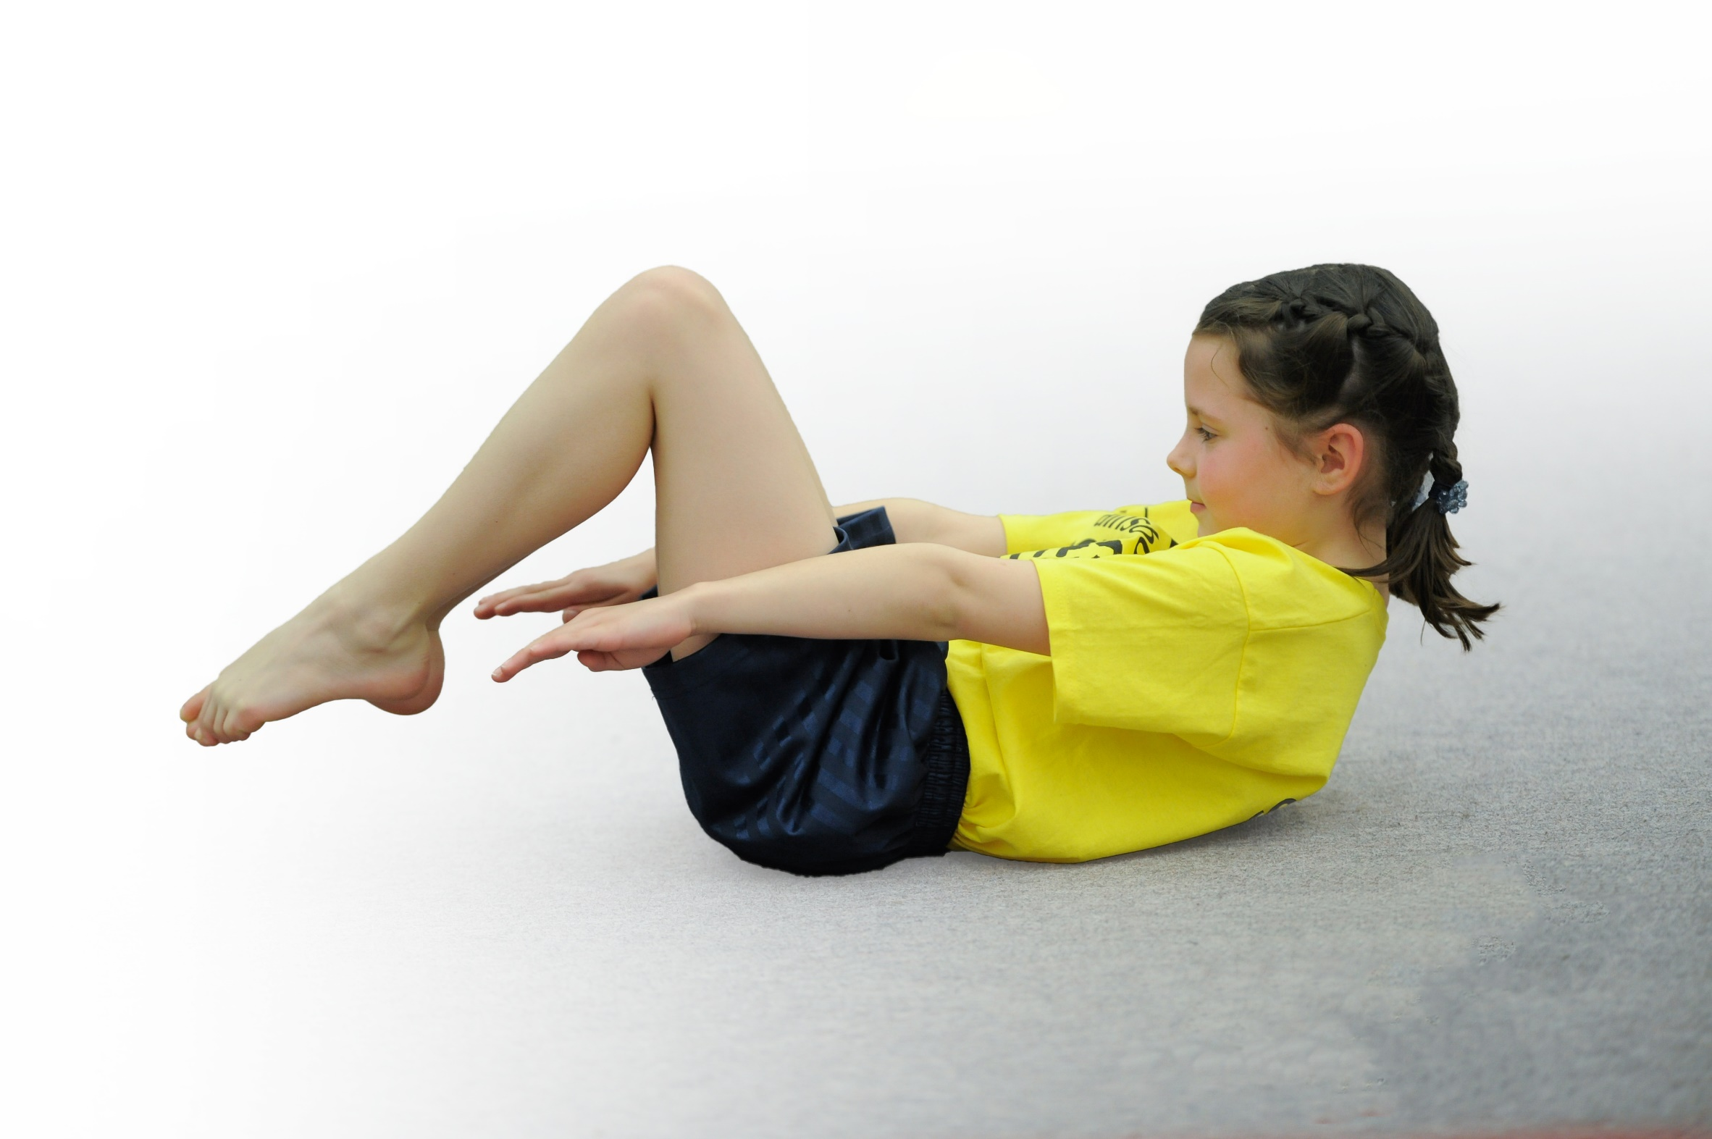
- build capacity and capability within the school to ensure that improvements made now will benefit pupils joining the school in future years

Please visit gov.uk for the revised DfE guidance including the 5 key indicators across which schools should demonstrate an improvement. This document will help you to review your provision and to report your spend. DfE encourages schools to use this template as an effective way of meeting the reporting requirements of the Primary PE and Sport Premium.

We recommend you start by reflecting on the impact of current provision and reviewing the previous spend.
Under the Ofsted Schools Inspection Framework, inspectors will assess how effectively leaders use
the Primary PE and Sport Premium and measure its impact on outcomes for pupils, and how effectively governors hold them to account
for this.

Schools are required to publish details of how they spend this funding as well as on the impact it has on pupils’ PE
and sport participation and attainment.
We recommend regularly updating the table and
publishing it on your website as evidence
of your ongoing review into how you are using the money
to secure maximum, sustainable impact. To see an example of how to complete the table please click HERE.

Support for review and reflection - considering the 5 key indicators from DfE, what development needs are a priority for your setting and your students now and why? Use the space below to reflect on previous spend, identify current need and priorities for the future.

Key achievements to date: | Areas for further improvement and baseline evidence of need:
- Staff confidence has been improved through CPD  - Equipment and resources are vastly improved.  - Progression in skills has vastly improved thought progression planning.  - More opportunity for children and parents to engage in keepfit activities.  - Competition engagement. | - Engage with active planner as part of the school games program to help encourage 30 active min per child  - Increase engagement in school games competition and apply for school games mark.  - Audit areas of the curriculum in order to highlight areas to upskill teachers.  - Look at developing change for life and sporting clubs that will target none engages and less active children.  - Continue to raise the profile of PE and sports within the school

Meeting national curriculum requirements for swimming and water safety | Please complete all of the below*:
What percentage of your current Year 6 cohort swim competently, confidently and proficiently over a distance of at least 25 meters? | 61.29%
What percentage of your current Year 6 cohort use a range of strokes effectively [for example, front crawl, backstroke and breaststroke]? | 61.29%
What percentage of your current Year 6 cohort perform safe self-rescue in different water-based situations? | 61.29%
Schools can choose to use the Primary PE and Sport Premium to provide additional provision for swimming but this must be for activity over and above the national curriculum requirements. Have you used it in this way? | No
*Schools may wish to provide this information in April, just before the publication deadline.

Action Plan and Budget Tracking
Capture your intended annual spend against the 5 key indicators. Clarify the success criteria and evidence of impact that you intend to measure to evaluate for students today and for the future.

Academic Year: 2017/18 | Total fund allocated: £ | Date Updated:
Key indicator 1: The engagement of all pupils in regular physical activity – Chief Medical Officer guidelines recommend that primary school children undertake at least 30 minutes of physical activity a day in school |  |  |  | Percentage of total allocation:
 |  |  |  | %
School focus with clarity on intended impact on pupils: | Actions to achieve: | Funding allocated: | Evidence and impact: | Sustainability and suggested next steps:
Afterschool clubs provided throughout the year for all year groups  - Develop and encourage parental involvement linked to physical activity  To have an active playtimes and lunchtimes  - Develop a more active playtime and lunchtime for children so the contributes to their 30 active min a day.  Promote walking month “May”  Walk to school week | - Find a suitably qualified coach that will facilitate this after school provision.  - Identify a staff member to be trained to undertake these activities  - Develop a plan to encourage parents ( develop a questionnaire what clubs would you like to see if there was parental engagement clubs)  Jodi.kean@newcastle.gov.uk (woman’s officers)  Introduce a club and introduce into KS2 parents a child club.  - Identify and train your leaders (hatrick deliver)  - Create a time table of activities and zone the yard  - Talk to all dinner staff regarding the program and time table.  - Purchase any equipment needs  - Develop a reward / celebration trip for young leaders (motivation)  - Identify TA to attend training with  Create a point system for walking to motivate children to see which class can walk the furthest in the month  Winning class will get a trip to trampoline park | £720  £ 300 class cover for developing plan  £2622  £200  £300 | pupils and parents attended an after school club which will include and variety of activities focusing on fitness and healthy active life styles  spring 2 data- 10 children and 10 parents form 3W and 4M at times other brothers and sisters have also attended  TA and couch working together to deliver the sessions  8 leaders trained  More children active and more active playground  Attitude to leaving and behavior improved  Kids more active and fitter in PE lessons.  Children that are not always engaged in activities are engaging  Children are being active on a daily basis and working as a team.  Children will be fitter due to walking to shops etc. This could encourage parents to also be more active | Aim to increases numbers and extend into KS1 to do this will need to run two clubs.  TA to work with another member of staff to up skill so no need for external coach  Aim to engage number of children who are active at play times  Young leaders run activities alone so no need for external coaches  TA to take over training
Key indicator 2: The profile of PE and sport being raised across the school as a tool for whole school improvement |  |  |  | Percentage of total allocation:
 |  |  |  | %
School focus with clarity on intended impact on pupils: | Actions to achieve: | Funding allocated: | Evidence and impact: | Sustainability and suggested next steps:
Have a celebration assembly for PE  PE celebrations added to school website to raise the profile of PE and sport for children parents and visitors to the website  PE notice board to keep children, staff and visitors informed of PE and sports opportunities.  Sports day | Have assembly every term  Regular update website with events, photos and news  Create and ensure this is updated regularly  Agree on a date and program of events for KS1 and KS2  Book summer hill bowling  Perches resources needed for this | £0  £150 | Increased awareness of what is happening regarding PE and sports at St Paul’s.  Photos, school website, letters to parents, celebration in sports assembly. Children will have been exposed to competitive activities in school | SLT are aware of PE and sort and the impact it is having across the whole school. They are committed to sustaining the current provision should the funding come to an end.  Run every year SLT have committed to this every year and will support the organization needed.

Key indicator 3: Increased confidence, knowledge and skills of all staff in teaching PE and sport |  |  |  | Percentage of total allocation:
 |  |  |  | %
School focus with clarity on intended  impact on pupils: | Actions to achieve: | Funding  allocated: | Evidence and impact: | Sustainability and suggested  next steps:
Improve staff knowledge, competence and confidence in teaching PE  perches of Newcastle PE and sports service to support and up skill the PE subject lead.  Upskill breakfast club and after school club to run a change for life sports club as part of the provision | Audit staff training needs  Hire a PE specialist to upskill and support teachers in PE lessons  Identify  -gymnastics  -dance  Regular half term meeting time tabled  Book PE service to deliver two supporting session in the summer term | £3000  £500  £0 | Photos on website, planning and teacher confidence survey  Notes from meetings, emails and confidence of PE lead  Numbers for after school and breakfast club participants , photos and confidence of staff | Staff will be confident enough to next school year delivers these two discipline within specialist intervention  Re audit and find new skills or confidence gaps.  Pay into this opportunity every year.  Staff are trained to deliver a change for life sporting club and staff will inform if new resources are needed or new ideas.
Key indicator 4: Broader experience of a range of sports and activities offered to all pupils |  |  |  | Percentage of total allocation:
 |  |  |  | %
School focus with clarity on intended  impact on pupils: | Actions to achieve: | Funding  allocated: | Evidence and impact: | Sustainability and suggested  next steps:
Additional achievements:  Develop a walking program that will be an opportunity for all class yr1-6 to take part in a “stamina walk”  Where appropriate it will be tied in with a topic the children are studying.  Each class to go to Vertigo climbing wall and trampoline pack - once over the school year so that can experience a new activity while also engaging in physical activity.  Attend all H A L events that are run by Newcastle PE and sports service to allow children to participate in health fun active nontraditional sports | Establish length of walk for each year group suitable for their age and route plans  Add to the school calendrer  Engage with the NCC walking officer david.luke@newcastle.gov.uk  Top up waterproof clothing  Add onto school calendar  Book and coordinate with both centers and arrange transport  Collect feedback and evidence from teachers and students  Add to school calendar  Book busses  Send letters | £1500  Climbing wall £900  Trampoline park  £420  Bus £900  £1000 | Children to develop a sustained fitness level that will benefit them outside of school as well  Promotes teachers fitness as well  Encourage a healthy active lifestyle.  Children will enjoy physical activity that is non traditional.  Encouraging a healthy active life style introducing children to places nearby that they could access out of school hrs  Notice board, photos, mentioned in PE celebration assembly school website, register of attendance | Once walks are planned they can be used year on year  Some children may attend these venues out of school due to developing an interest.  Commitment from SLT to support this as they understand the benefit of leading a health active life style.
Key indicator 5: Increased participation in competitive sport |  |  |  | Percentage of total allocation:
 |  |  |  | %
School focus with clarity on intended  impact on pupils: | Actions to achieve: | Funding  allocated: | Evidence and impact: | Sustainability and suggested  next steps:
Establish a quick sticks hockey competition (intra school)  - Children will be exposed to completion within school and this will lead as a path way for More able to take part in city comps  Engage with the school games program so that children are engaging in competitive opportunities though out the school year.  Take part in Trust competition including Football | - Establish when level to will take place  - Term prior teach hockey in curriculum time  - Upskill staff that are new to KS2  - Organize date between two classes or just a class to run comp in school (level 1)  - Book coach to help support running of comp  - Buy meddles  - Contact Ian Kendal  Book opportunities for children and add to school diary  Ensure PE calendar links with school games  Highlight G and T children for competition.  Focus on attending the gymnastics competition due to having had CPD on this during this academic year and it being the first time we have attended 22d May 23rd May  Add to school calendar  Prepare children for competition arrange lifts | £100  £2000 (bus and staff cover) | Participation figures  on notice board  Children’s comments and pics on school website  Engaging in comp  Photos, website, certificates and medals, participating figures  Photos, website, certificates and medals, participating figures | Staff have been trained in order to continue running these events in school.  SLT know the importance of competitive engagement and are committed to continuing to support this.  SLT know the importance of competitive engagement and are committed to continuing to support this.

