**Tap up Challenge**

* **To measure hand – eye co-ordination**
* **How many times can you tap the ball up with the racquet/bat before the ball hits the floor.**
* **No bat? No problem – do the same challenge with your hand held out flat in front of you.**

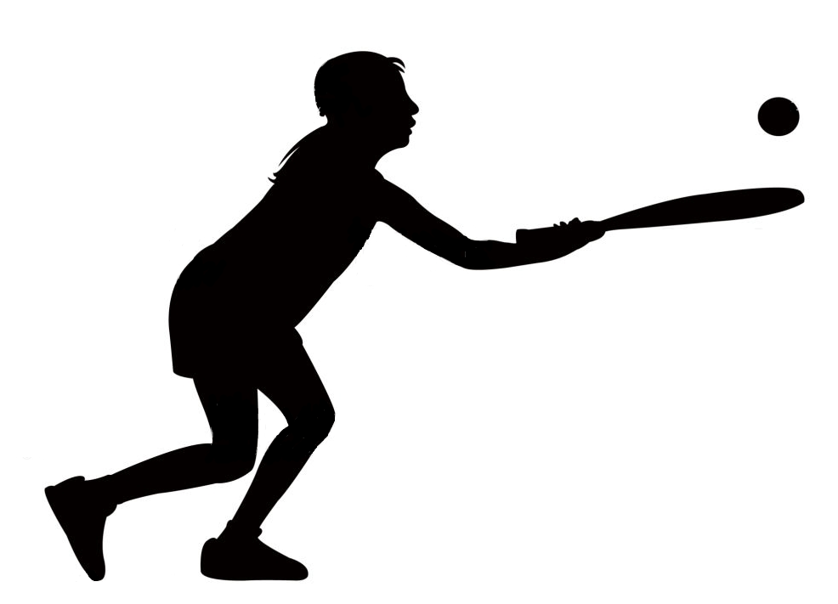



“Can you beat your own score?”  
That’s the challenge!