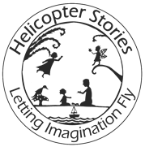

The Poetry Basket
Autumn Term
September to December
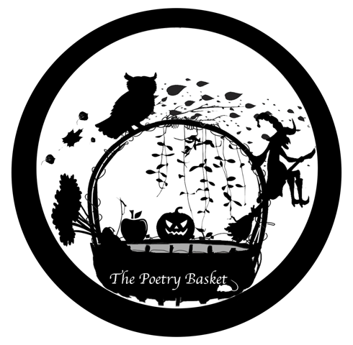

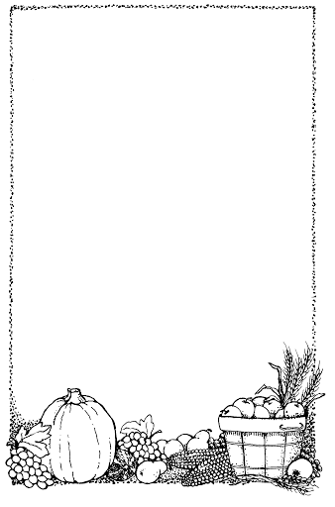
Poems
Chop Chop____________ 3

Wise Old Owl 4

Falling Apples 5

A Basket of Apples _______ 6

Leaves Are Falling ______ 7

Breezy Weather 8

Who Has Seen the Wind? by Christina Rossetti 9

Cup of Tea________________ ______ 10

Mice by Rose Fyleman 11

Shoes_____________ 12

Chop Chop

Chop, Chop, Choppity Chop.

Cut off the bottom and cut off the top.

What there is left, we put in the pot.

Chop, Chop, Choppity Chop.

Wise Old Owl

A wise old owl sat in an oak,

The more he heard, the less he spoke.

The less he spoke, the more he heard.

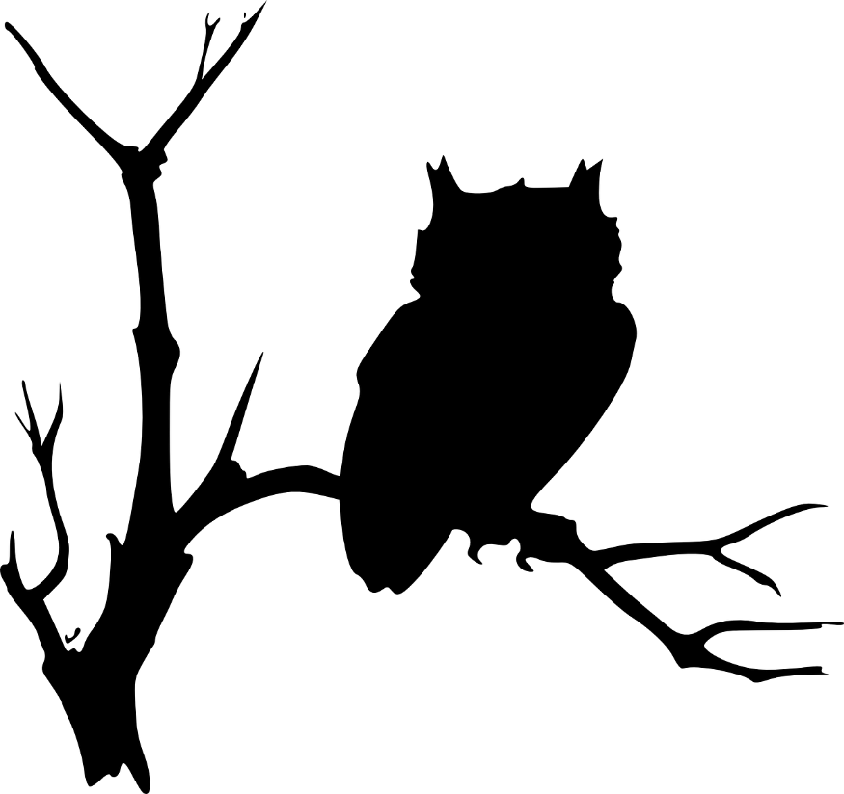
Why aren’t we all like that wise old bird?

Falling Apples

Here is the tree with its leaves so green.

Here are the apples that hang between.

When the wind blows, the apples will fall.

And this is the basket to catch them all.
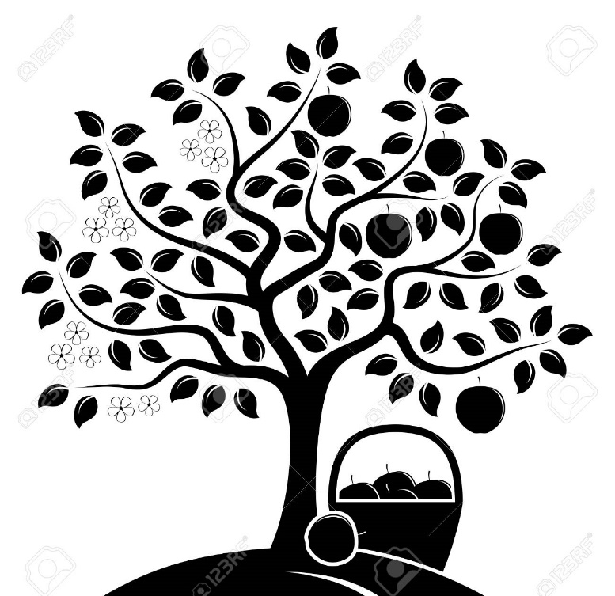

A Basket of Apples

I’ve got a basket of apples, picked from a tree.

Apples rosy red for you, and shiny green for me.

Some of them are big, and some of them are small.

Some of them are oval, and some shaped like a ball.

Some of them are sour, and some of them are sweet.

Lots of lovely apples for you and I to eat.

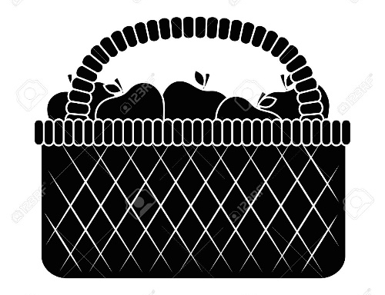

Leaves Are Falling

Leaves are falling, leaves are falling,
One fell on my nose.

Leaves are falling, leaves are falling,
One fell on my toes.

Leaves are falling, leaves are falling,
One fell on my head.

Leaves are falling, leaves are falling,
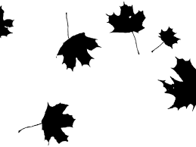
Yellow, Orange, Red.

Breezy Weather

Breezy weather. Freezy weather.

When the leaves fall, we all fall together.

Breezy weather. Freezy weather.

When the wind blows, we huddle together.

Who Has Seen the Wind?
by Christina Rossetti

Who has seen the wind?

Neither I nor you.

But when the leaves hang trembling,

The wind is passing through.

Who has seen the wind?

Neither you nor I.

But when the trees bow down their heads,

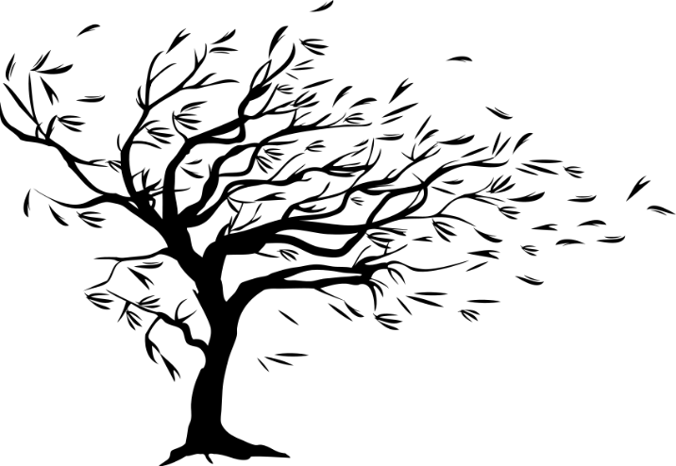
The wind is passing by.

Cup of Tea

Here’s a cup,

And here’s a cup,

And there's a pot of tea.

Pour a cup,

And pour a cup,

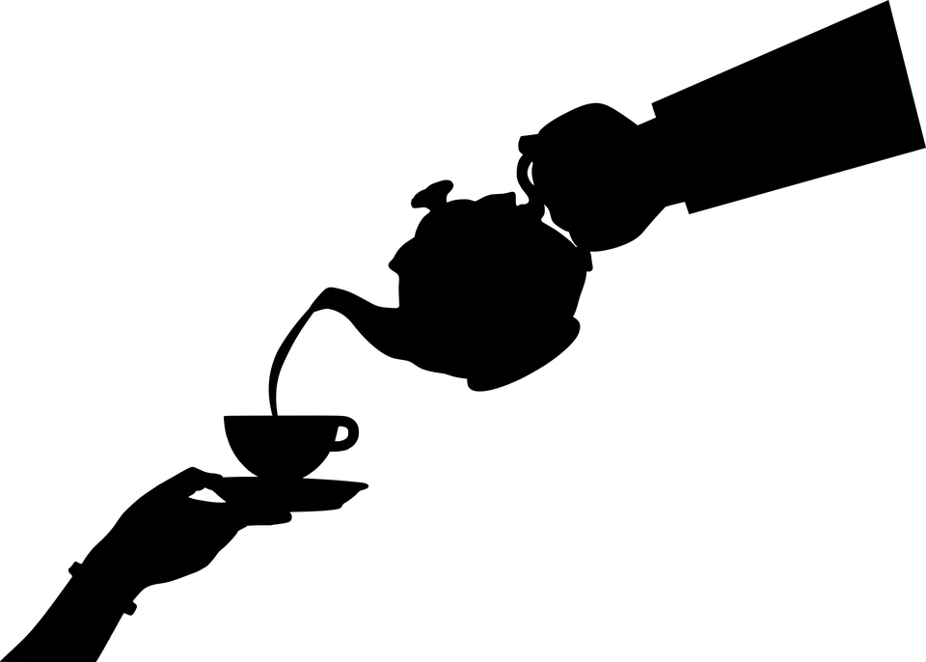
And have a drink with me.

Mice by Rose Fyleman

I think mice are rather nice.

Their tails are long, their faces small,

They haven’t any chins at all.

Their ears are pink. Their teeth are white.

They run around the house at night.

They nibble things they shouldn’t touch.

And no-one seems to like them much.

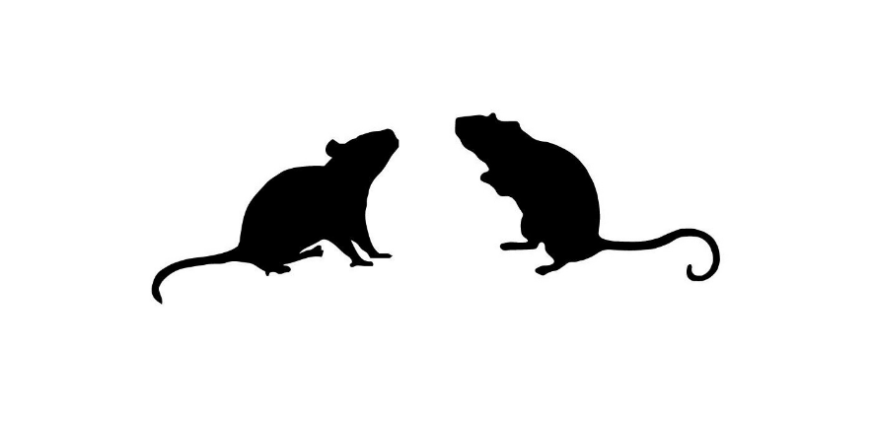
But I think mice are nice.

Shoes

Before I jump into my bed,

Before I dim the light,

I put my shoes together,

So they can talk all night.

I'm sure they would be lonesome,

If I tossed one here or there,

So I put my shoes together,

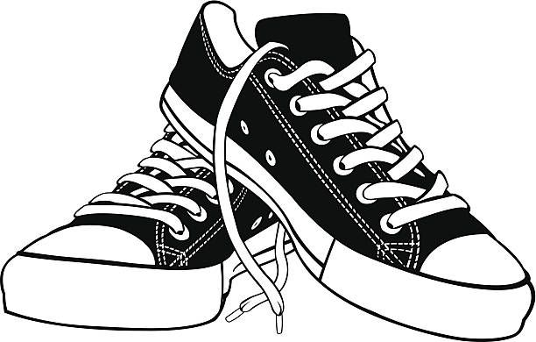
For they are a friendly pair.

