

At St Paul’s School we shall glorify the One God, Father, Son and Holy Spirit, by providing an excellent education which academically and socially enables all pupils to achieve beyond their expectation.
Our School

St Paul’s Primary school is a fully inclusive school. As a school we believe that children of all backgrounds and cultures should be welcomed and valued. We recognise and value the needs and potential of each and every child. We ensure that we consistently provide the children with high-quality, differentiated teaching, to enable every child’s needs to be met. We strive to make sure that every child is provided with a rich and exciting curriculum to help them to develop into creative, successful and inquisitive young people who can look back at their time at St Paul’s with happiness and pride.

SEND information

This report is intended to give families information about the way in which we support all children, including those who have Special Educational Needs or Disabilities (SEND) in order for them to reach their full potential. This document will outline the strategies, resources and provision used in our school so that the needs of all children can be met. We understand that every child is unique and we strive to find the support which is best suited to them.

“A child or young person has SEN if they have a learning difficulty or disability which calls for special educational provision to be made for him or her.”
(SEN Code of Practice, 2014)

There are many reasons why a child may be identified as having SEN:
- They may be having significant difficulty with their learning and could be making less progress than would be expected.
- They may have or be suspected to have a specific learning need, for example dyslexia.
- They may have social or emotional difficulties.
- They may have difficulty in communicating and interacting with others.
- They may have a sensory or physical need, for example a hearing impairment.

When a child is indentified as having SEND we provide them with an Individual Education Plan (IEP). This plan aids communication between parents and teachers and it consists of personal targets for the child which are reviewed termly. We have a dedicated team in place to ensure that children with SEN receive the best support for them. In addition to the fully qualified Special Educational Needs and Disabilities Leader (SEND Leader), the team consists of a number of Special Educational Needs Teaching Assistants (SENTA), SEN Governor, Family Support Worker and Attendance Officer. As a school we have also have excellent links with various professionals from a wide range of outside agencies.

Other useful documents such as our SEN, Inclusion and Accessibility policies can be found on our website http://www.stpauls.newcastle.sch.uk/website

Parents can also access their local Newcastle Special Educational Needs and Disabilities Information, Advice and Support Service by contacting officer Judith Lane on 01912840480 or juidth.lane@newcastle.gov.uk
She will be able to provide impartial information, advice and support in relation to their child’s SEN and /or disability.

If you would like any further information about what St Paul’s can offer then please do not hesitate to contact the SEND Leader, Rachael Taylor, on 01912733667.

Reviewed and amended- September 2015, September 2016, September 2017, January 2018, January 2019, January 2020.

School entitlement offer to pupils with additional needs
For all pupils at St Paul’s School who have an additional need:
- We recognise that the family is the expert on their child and work in partnership with them;

- We use child-friendly Individual Education Plans (IEPs). We involve pupils, parents and staff in the writing, reviewing and implementation process;

- We deliver high quality teaching, differentiating the curriculum and resources to meet the needs of individual pupils and to promote pupil progress;

- We plan, assess, do and review;

- We seek advice and support from outside agencies to ensure any barriers to success are fully identified and responded to;

- We ensure there is access to teaching and learning for pupils with SEND, monitored through the school’s self-evaluation process;

- We evaluate the success and outcomes of our intervention programmes regularly;

- We use strategies to reduce anxiety/promote emotional wellbeing;
- We understand that every teacher is a teacher of SEND. We believe that each pupil entitled to support from the class teacher as well as from our highly-skilled teaching assistants;

- We have a communication system in school to ensure that appropriate information is passed between teachers, support staff and the SEND Leader;

- We have a fully-qualified SEND Leader who can provide support and guidance for staff;

- We hold review meetings for children with SEND, to which parents are invited to attend;

- All staff have completed, and will continue to receive on-going training in relation to meeting pupils’ needs in the classroom;

- We offer support to families and they are signposted to services and organisations which may offer appropriate support or advice via the Local Offer;

- We support families with children with SEND formally through review meetings and informally through our ‘open door’ approach;

- And we offer support to all pupils and parents during all periods of transition.

St Paul’s Church of England Primary School
Special Educational Needs (SEN) Information

Type of SEN for which provision is made at St Paul’s C of E Primary School | Type of support/provision made at St Paul’s C of E Primary School
Communication and Interaction  This may include;  - Autistic Spectrum Disorder (ASD)  - Speech, Language and Communication Needs (SLCN)   | - Visual timetables may be used to support children  - Support and supervision during less-structured times of the day (e.g. break/lunchtime)  - Social skills support through one-to-one and small group intervention  - Strategies and programmes to support speech and language development  - Areas with reduced distraction and low stimulus to enable children to focus  - ICT is used where possible to reduce barriers to learning  - Support and resources to reduce anxiety and promote emotional wellbeing e.g. fiddle toy, stress ball  - Opportunity to communicate in different ways e.g. home-link book in Early Years  - The option to communicate using Makaton if this is appropriate  - Small group or one-to-one support for developing pupils speech, language and communication following programmes of work provided by outside specialists such as speech and language therapists  - Access to expertise and advice of the local authority Speech, Language and Social Communication team  - Where appropriate we individualise reward systems to promote learning and enhance self-esteem  - A level 3 teaching assistant who specialises in Speech and Language
Cognition and Learning Needs  This may include;  - Learning Difficulties (moderate-MLD)  - Specific Learning Difficulties e.g. dyslexia, dyscalculia, dyspraxia (SpLD)  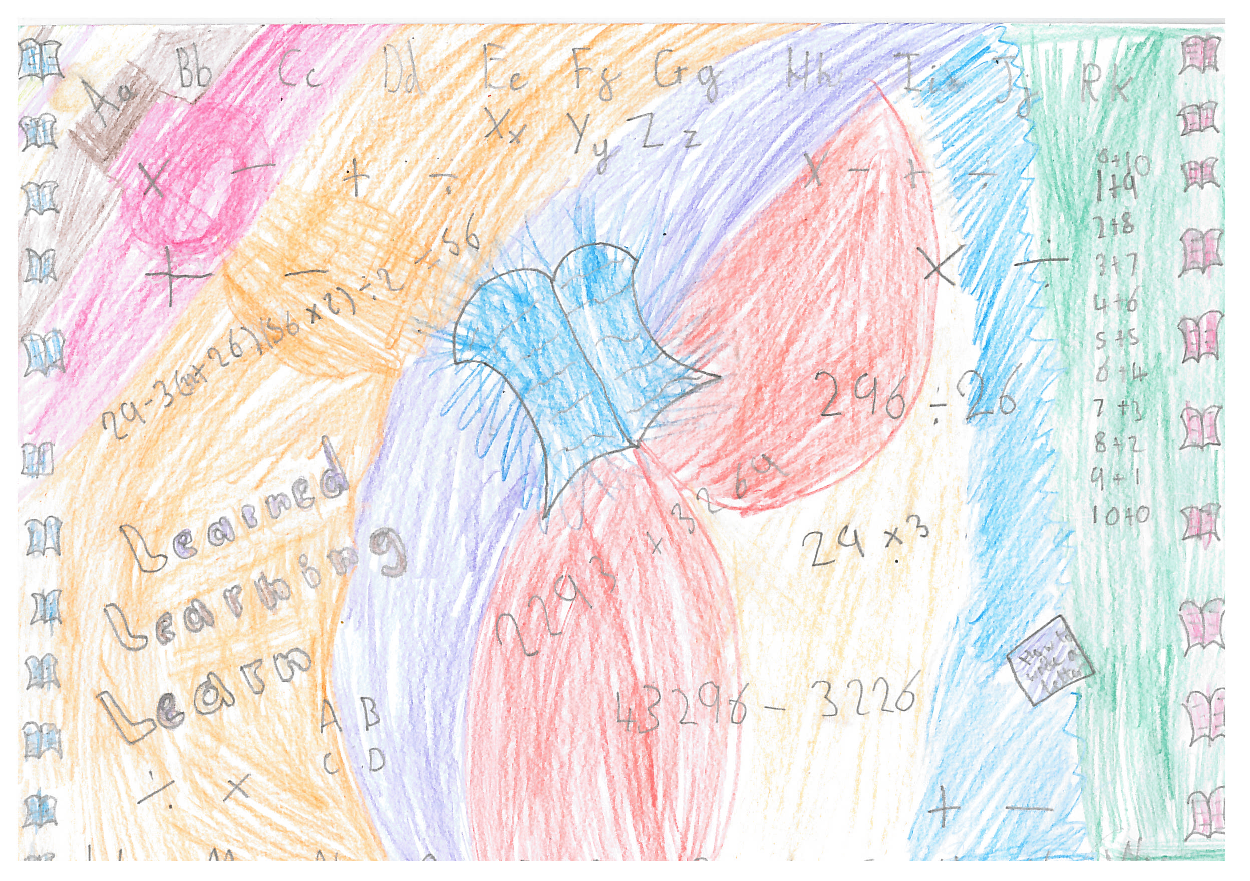 | - Strategies to promote and develop literacy and mathematical skills with increasing independence  - Resources to promote multi-sensory, practical and independent learning  - Small group targeted intervention work such as ‘Lexia’  - One-to-one intervention work such as ‘Toe by Toe’  - Small group or one-to-one sessions to improve skills in a variety of areas e.g. social skills, handwriting and memory skills  - Small group or one to one intervention work with a non-class-based teacher or highly-skilled support assistant  - Reduced class sizes for maths in some areas of the school  - Provision of table top resources to promote independence and ensure that learning is multi-sensory and practical  - Alternative approaches to recording promoted  - Opportunities for repetition of key learning  - Advice, support and training from outside agencies  - Differentiated and, where applicable, individually personalised homework  - Additional small group support in class from the class teacher and teaching assistant  - Small group Phonics sessions daily across Early Years and Key Stage 1  - Differentiated Phonics teaching and repetition if necessary  - Use of support materials such as Numicon  - Strategies and resources to support dyslexic pupils e.g. coloured over-lays, word banks  - Additional processing/thinking time and the opportunity to share ideas  - Multi-agency involvement with the family as required  - Regular assessment of pupils is reported to staff and parents  - Assess access arrangements for SATs testing and provide appropriate arrangements  - ICT supports our curriculum, for example the use of ipads and appropriate apps  - Support from EAL teacher for pupils with English as an Additional Language (EAL)  - We have the Dyslexia Friendly School Award  - A level 3 support assistant who specialises in SEN and Specific Learning Difficulties  - Groups to support developing Memory skills, including the use of ‘Hear Builder’.
Social, Emotional and Mental Health Difficulties  This may include;  - Social difficulties  - Mental health conditions  - Emotional difficulties  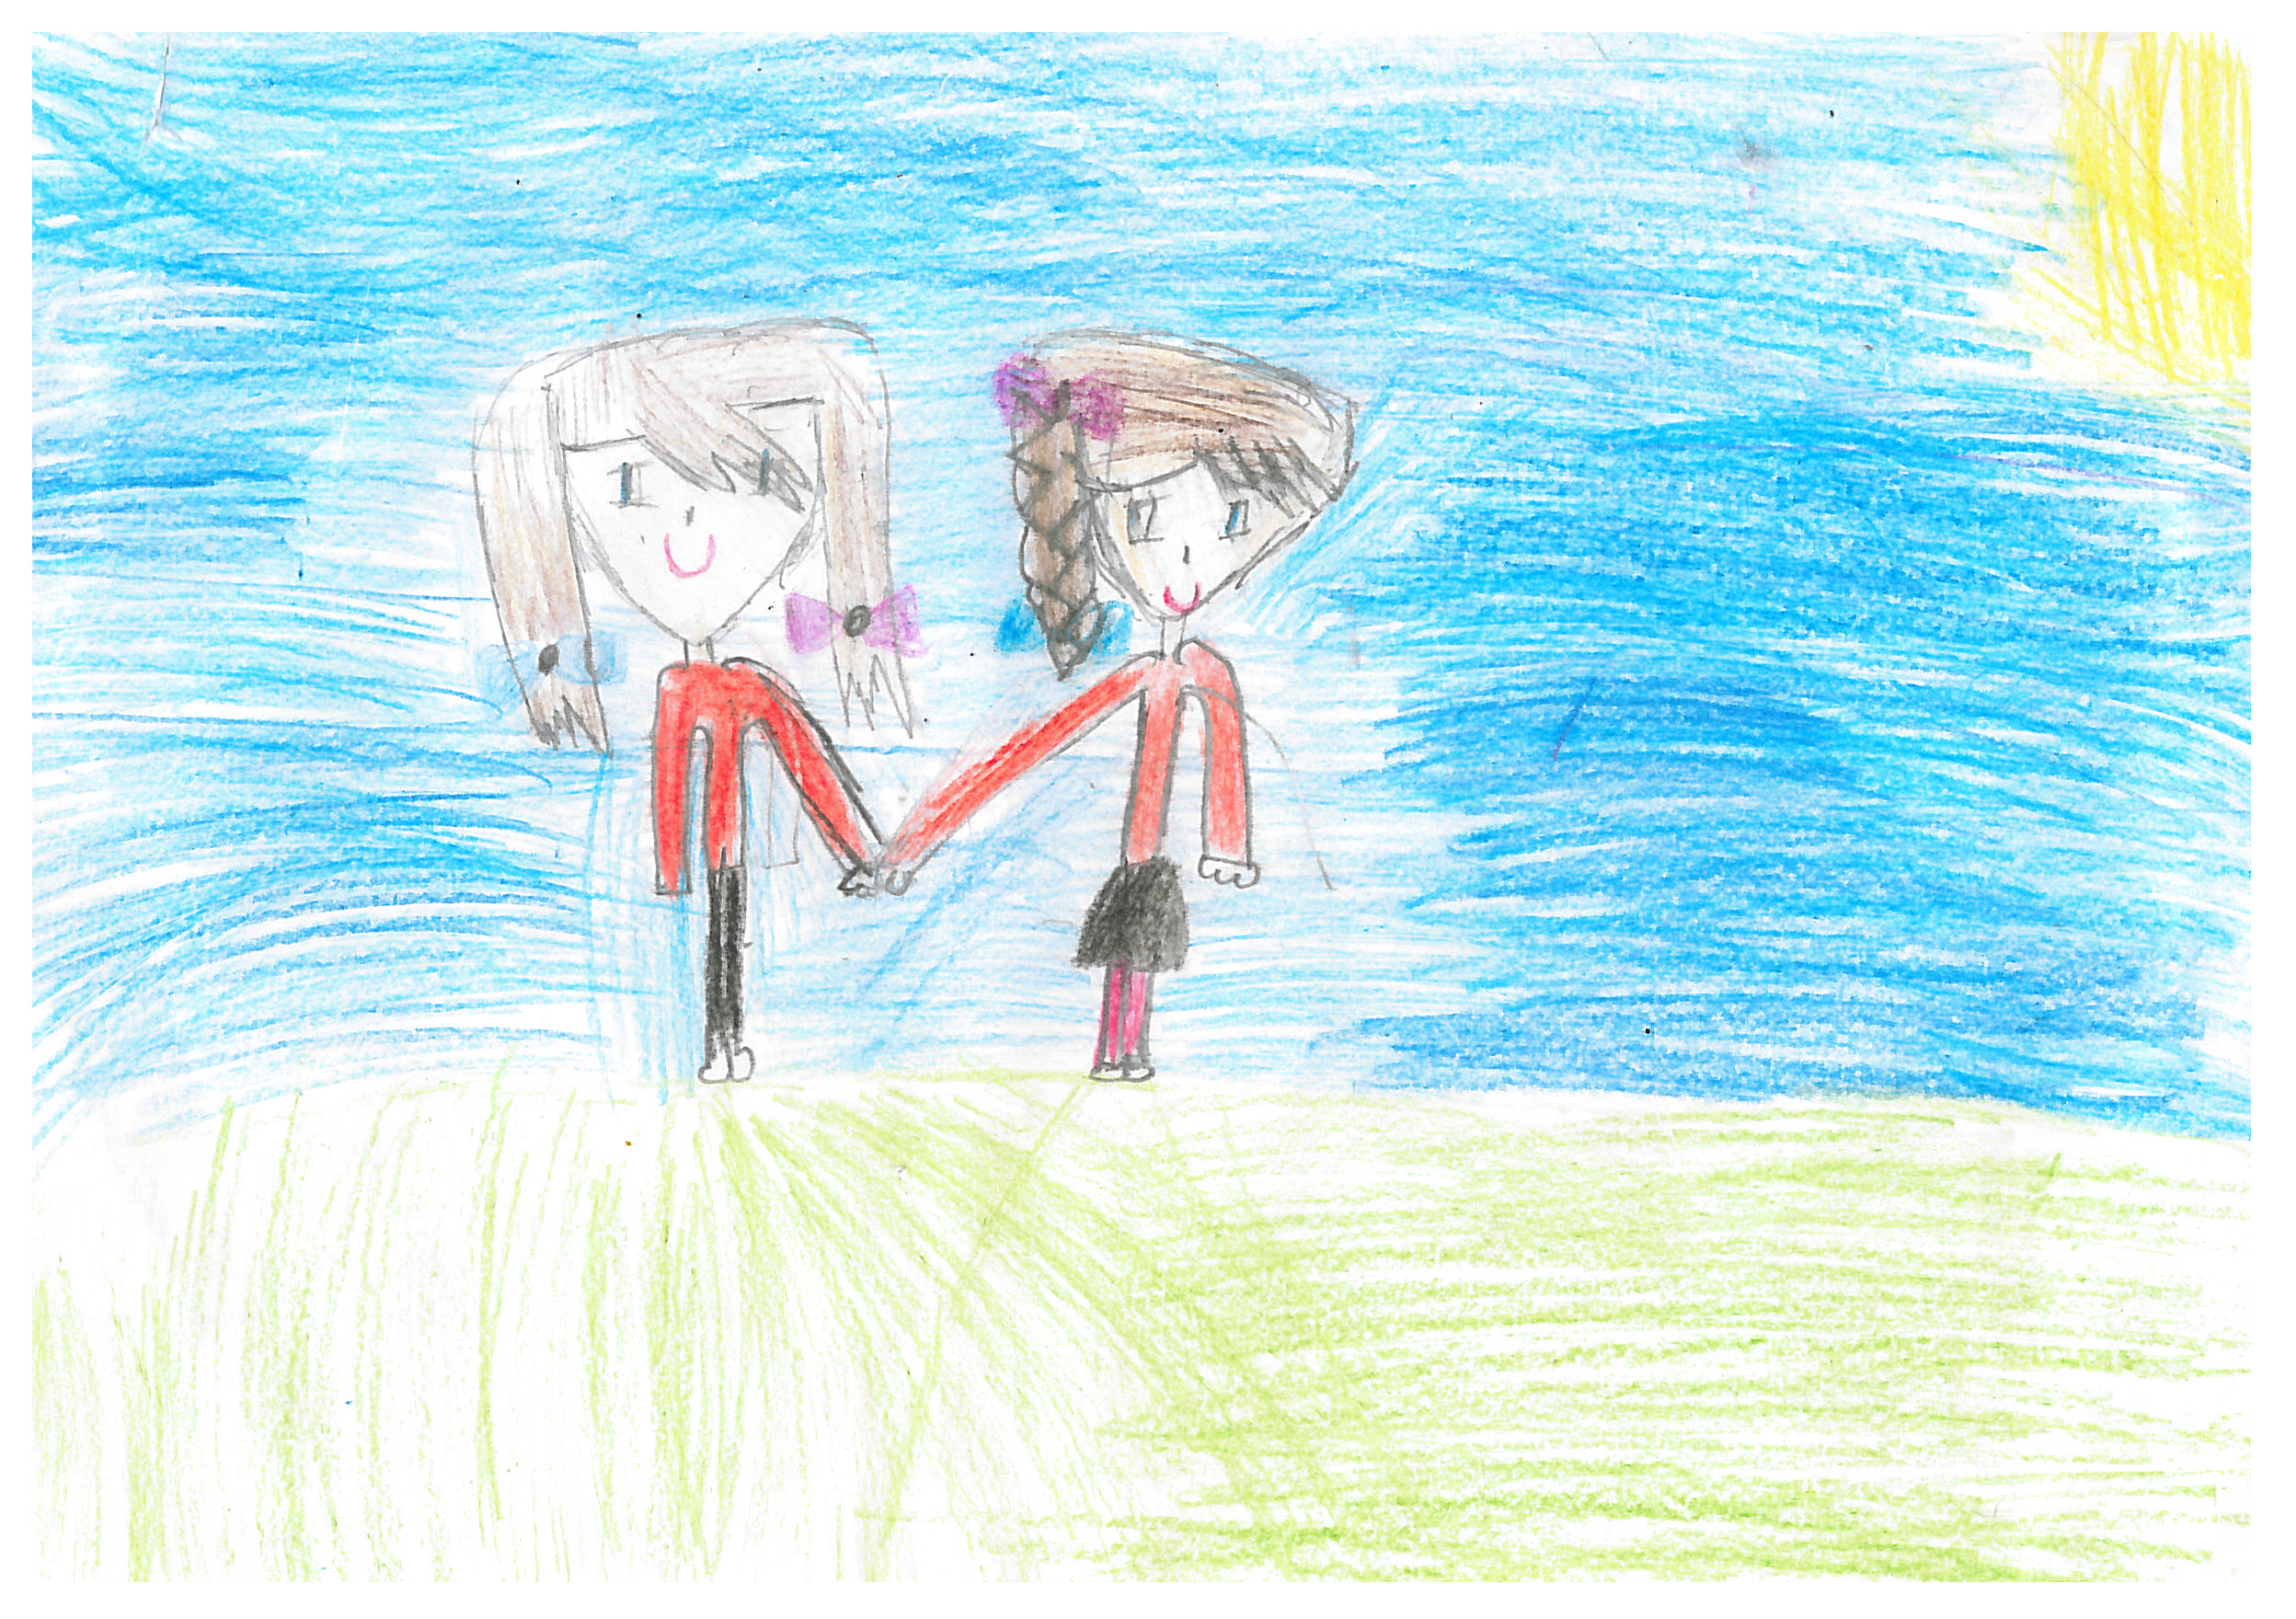 | - Excellent pastoral care is provided to our children by a very caring staff team  - Every child is valued  - A consistent use of rewards and sanctions throughout the school (see Learning Behaviour Policy)  - Risk assessments are used to ensure the safety and inclusion of all pupils in all activities  - Small-group or one to one targeted support to improve social skills and emotional resilience  - Referrals to specialist outside agencies are made where appropriate (Educational Psychology Service, Children and Young People’s Service)  - Children can gain bronze, silver, gold and platinum certificates by collecting stars as a reward for good behaviour/work  - Opportunities to attend residential trips in upper KS2 which help to promote social, emotional and behavioural resilience and independence  - Support and additional preparation for tests  - Additional assessments that focus on emotional development  - Staff trained in positive handling  - Advice and training from outside agencies
Sensory and/or Physical Needs  This may include;  - Hearing Impairment (HI)  - Visual Impairment (VI)  - Multi-sensory Impairment  - Physical Disabilities  - Medical Needs  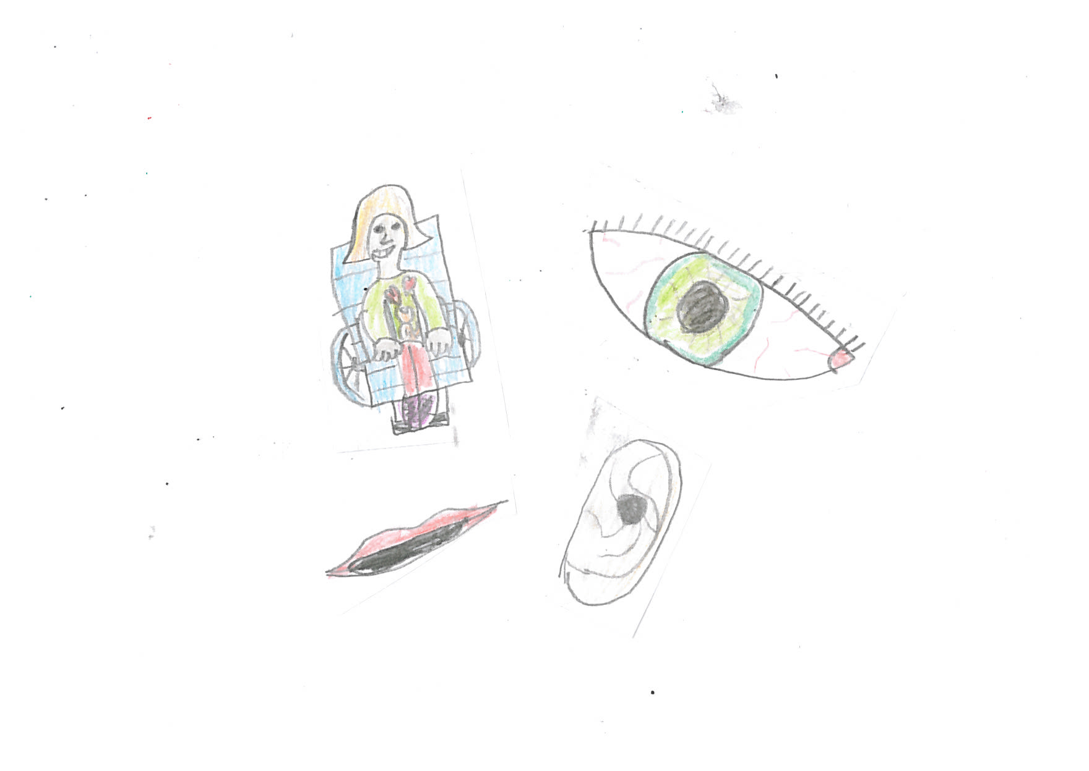 | - Advice is sought and acted on for pupils with significant medical needs  - Support and aids are provided to ensure children can access the curriculum and develop independent learning  - Staff work with specialists such as ‘The Hearing Impairment Service’ or a member of the ‘Visually Impaired Team’ to seek advice and guidance on meeting the needs of individual pupils  - Support is given to Occupational Therapy, Physiotherapy, Hydrotherapy and Re-bound therapy programmes  - Support with personal and intimate care is provided if and when needed  - There are entrances to our school which allow wheelchair access  - Classrooms are relocated to meet access needs when required.  - The school has disabled toilets/facilities  - Small group or one-to-one targeted intervention programmes are delivered to pupils to improve skills e.g. fine and gross motor skills  - Our staff receive training to ensure they understand the impact of a physical/sensory need on teaching and learning  - Our staff understand and apply the medicine administration policy.  - There is a designated medical officer who regularly checks medical records and ensures that staff understand and apply the medicine administration policy.  - Designated first aid trained staff are assigned to each class.  - Fracture Management Plans are put in place if necessary.  - Our school works hard to ensure that parents/carers are able to work in partnership with us to support their children.  - Support is offered to families and they are signposted to services/organisations which may offer support/advice where appropriate, via the Local Offer.

St Paul’s Church of England Primary School
Special Educational Needs and Disabilities (SEND) Information

If you have any concerns about your child’s SEND, provision or progress we would urge you to come into school and discuss matters further with your child’s class teacher or the SEND Leader.

For additional information, support and contact details please visit-

https://www.newcastlesupportdirectory.org.uk/kb5/newcastle/fsd/localoffer.page?localofferchannel=0

