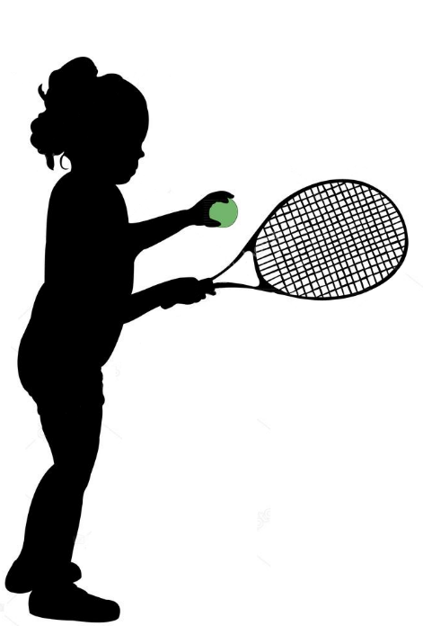

**Off the wall Challenge**

* **To measure hand – eye co-ordination**
* **How many times can you hit the ball off the wall, only allowing the ball to bounce once on its return.**
* **No bat? No problem – do the same challenge with your hand held out flat in front of you.**



“Can you beat your own score?”  
That’s the challenge!